The Bus Beacon
An Age-Friendly Smart City solution developed by Leeds City Council

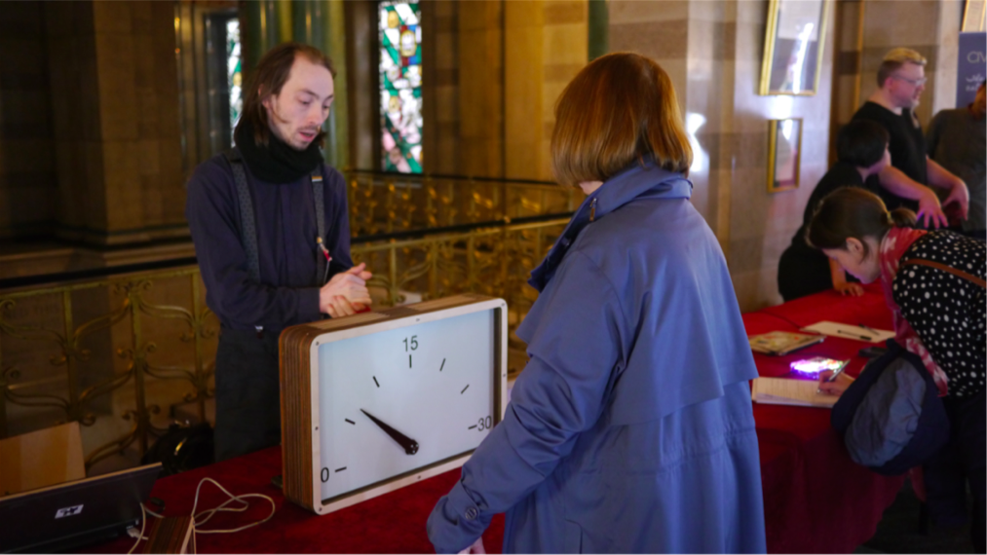

www.SustainableDevelopmentLab.com
What is the Bus Beacon?
The Bus Beacon is a portable device that shows the user the amount of time remaining for their bus to arrive at their nearest stop. Currently the only way to access this information is by physically going to the bus stop, using a smart device or a desktop computer. Early usability workshops relating to transport revealed that elderly and vulnerable people tend not to use such devices. The Beacon brings information to an individual’s home or in a public location. Access to this information gives users greater confidence in traveling to the bus stop and using public transport for essential journeys.

Who is the user or target audience?
The Bus Beacon has been designed for older people. It can be installed in individual homes, sheltered care homes and housing complexes. We have conducted usability testing with users from these locations to define the features of the Beacon. The Beacon is also suitable for public locations such as hospitals, supermarkets and doctor’s surgeries. These public locations are either served by one bus or have one route that connects them to the city centre.

An accessible and affordable solution
We carried out extensive usability testing with older people to identify the physical specifications of the Bus Beacon. As a result, we have developed a wall mounted and desktop version. These devices use open data and feature an analogue countdown timer that shows the amount of time remaining for the bus to arrive at a bus stop nearest to the user. This data is sourced from GPS transponders on the buses, so the countdown constantly adapts to any delays that might occur, continuously displaying a best estimated time until the bus arrives.

What are the benefits of the Beacon?
The Bus Beacon gives older people more confidence in using public transport by bringing travel information to them without the need for expensive or complicated technology. It is an accessible and affordable solution that can support a paperless initiative.

How can you participate?
After carrying out extensive user testing in the development phase, we want to evaluate the impact of this device in real-life situations. We will develop and install 4 beacons in public or private locations and evaluate them over a 1-month period. This includes two desktop and two wall mounted beacons. The costs for this are £6000. This funding will help us procure hardware components to assemble the beacons, install them on the test sites and monitor usage. The funding will also allow us to carry out design work and production of a version 3 prototype, which would be silent, feature a few aesthetic improvements, and once designed will potentially reduce the material and production costs per prototype unit.

What happens next?
We anticipate that a V3 prototype would be the last required before looking into options for industrial design. Should the pilot demonstrate need and behavior change, we will create a robust business plan to take the solution to market. At this stage you may choose to come onboard as an early stage investor with a revenue share agreement. As an early adopter of this cutting-edge and scalable solution you will receive all subsequent software upgrades for free and hardware components at cost.

Technical Specifications

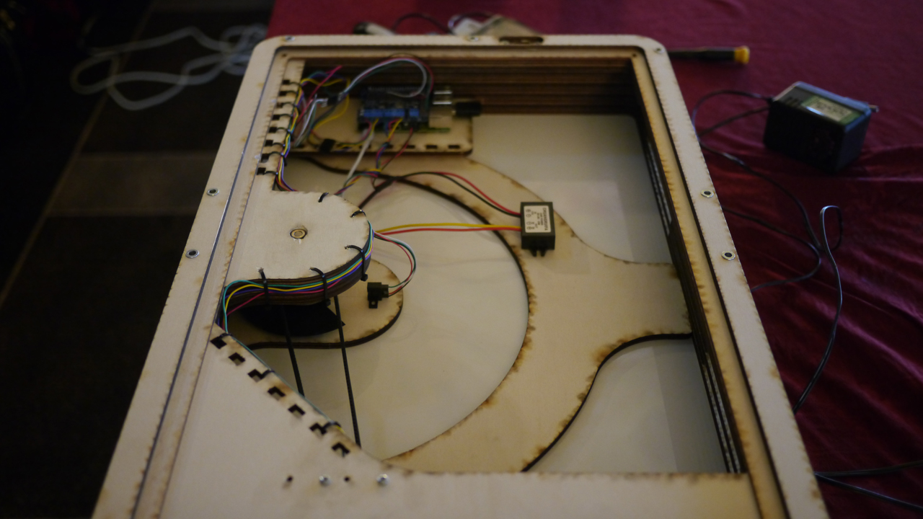

A wall mountable housing roughly 600x400mm contains a semi-circular clock face, with a single large hand. Through a Wi-Fi or 3G internet connection, for a given bus route and stop, the Bus Clock takes transit data directly from Leeds Metro, and displays a real-time countdown to the next bus departure. This data is sourced from GPS transponders on the buses, so the countdown constantly adapts to any delays that might occur, continuously displaying a best estimated time until the bus arrives. LED lights indicate that the unit is powered on and receiving data, and when applicable, if there will be no bus within 30 minutes.

Current Status
At present, we have been through two iterations of design and physical prototyping. Soak testing has taken place primarily for the Over Well Lane bus stop (450 13146), on the 97 bus route. we would like to choose a site to install our current prototype for real world testing.

Contact
If you would like to participate or have any questions, please contact:
Abhay Adhikari – contact@sustainabledevelopmentlab.com

