Guidance to filter the data to show only wheelchair accessible vehicles

- Visit the page of the data mill north showing the list of all taxi and private hire vehicles

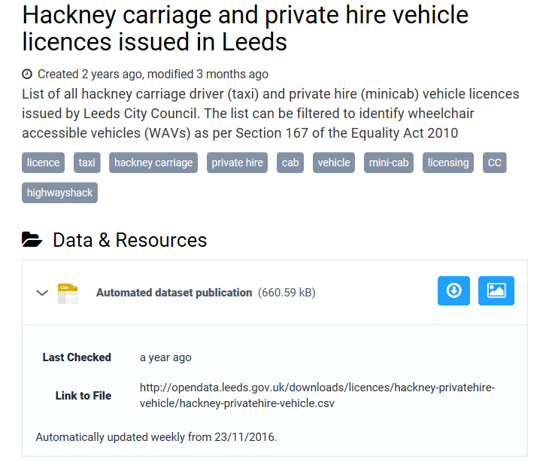

- Click on the blue downward arrow icon to download the data.

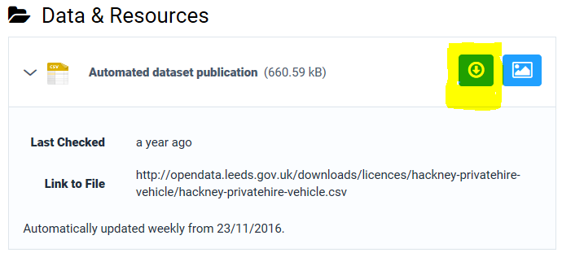

- This will open a new spreadsheet hackney-privatehire – vehicle.csv

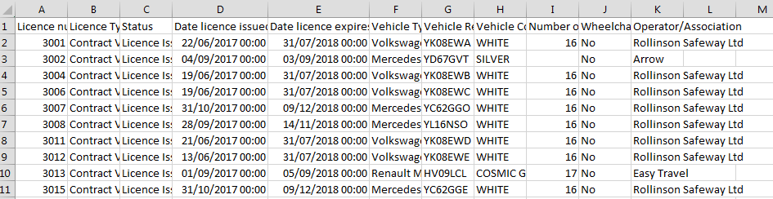

4.Select the Data tab, then click the Filter command.
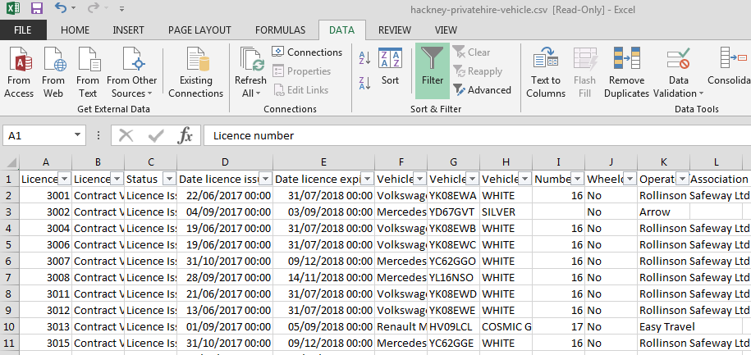

5.Drop-down arrows will appear in the header of each column.
6.Click the drop-down arrow for the column you want to filter. In this case, filter the Wheelchair column to view only vehicles which are wheelchair accessible, by ticking the boxes next to the data you want to view.
9.Click OK. All other data will be filtered, or temporarily hidden.
