Preliminary flood risk assessment review
Self-assessment form | January 2017

This self-assessment form is provided to enable each lead local flood authority (LLFA) in England to complete the first review of its preliminary assessment report and identification of flood risk areas (FRAs), as required by the Flood Risk Regulations (2009).
Who should complete this self-assessment?
Every LLFA in England should complete parts A, C and D of the self-assessment form and submit it, with the additional information requested in sections C3 and C4, to the appropriate Environment Agency Partnership and Strategic Overview team no later than 22 June 2017.
All LLFAs should read the guidance document 'Preliminary flood risk assessment review: guidance for lead local flood authorities in England' before completing the self-assessment form.
Part A - LLFA contact information
Name of LLFA | Leeds City Council
Name of LLFA officer submitting the assessment | Janet Cassidy
Job title | Asset Engineer
Telephone number | 0113 37 87304
Email address | Jan.Cassidy@leeds.gov.uk
Name of LLFA officer approving the assessment | Jonathan Moxon
Job title | Flood Risk Manager
Date submitted to Environment Agency | 22/06/2017
Link to PFRA report 2011 | http://www.leeds.gov.uk/docs/Leeds%20PFRA%202011.pdf

Part B - to be completed by the Environment Agency
Name of Environment Agency officer receiving the completed assessment | Lisa Killick
Job title
Date assessment received from LLFA
Date assessment agreed with LLFA

Part C - LLFA self-assessment
PFRA report section | Activity for PFRA/FRA review | Yes/No | Summary description | Actions planned in response
1. Governance and partnership | 1.1 Since publication of the PFRA in 2011, have there been any changes to, or creation of new, risk management authorities (RMAs) with responsibilities in the LLFA area? | No | There has been no change to, or creation of new RMAs. RMAs are: Leeds City Council as LLFA, Leeds City Council as Highway Authority, Environment Agency, Yorkshire Water, Ainsty IDB, Highways England (formerly Highways Agency). | No action is required.
 | 1.2 Are all roles and responsibilities for collecting and recording flood risk data and information clearly defined, including the respective roles and responsibilities of upper and lower tier authorities and other RMAs where relevant? | No | Leeds City Council is an upper tier authority, there are no lower tier authorities. There is a duty for RMAs to co-operate with each other and to share data when necessary. Each RMA records instances of flooding to their assets on independent databases. This data is shared on request, for example Section 19 flood investigation reports. | Continue maintaining and sharing relevant datasets when necessary.  RMAs should aim to work toward recording flood risk data in a common format that allows exchange of data between independent systems in the most efficient way possible. A new asset management system is due to be put in place from September 2017, which will improve the ability to manage and share data in this way.
2. Data systems and management | 2.1 Do you have an up to date record of relevant sources of flood risk data and information for the LLFA area, including those held by other organisations? | Yes | Leeds City Council holds a GIS workspace that links all relevant sources of flood risk data from RMAs and other stakeholders. Data is updated on request, usually annually, but also when necessary for specific reports, projects and investigations. | Continue maintaining and sharing relevant datasets when new information is made available with RMAs.
 | 2.2 Have sources of ‘locally agreed surface water information’ been established and maintained for the LLFA area and agreed with relevant partners? | Yes | "Locally agreed surface water information" comprises the 2011 PFRA and the Environment Agency Risk of Flooding from Surface Water (RoFSW) is understood and agreed between partners and LCC to be the most suitable source for surface water information. | Continue to update flood risk management partners where RoFSW does not sufficiently represent real life conditions.
 | 2.3 Are systems in place to collect, record and share data and information for the purpose of assessing flood risk in the LLFA area? | Yes | Incidents of flooding are reported to a central call centre, then referred to the appropriate department, where they are recorded on independent databases.  This data can be accessed and shared using the database itself, or by using the GIS workspace described above.  Surveys of floods are carried out in response to flood incident reports, as well as during significant flood events. Documents, such as photographs and drawings are located within a networked folder and used as a reference of flooding for studies. | A new call centre system is due to be introduced. This provides the opportunity for every department to flag flooding reports, so that this information can be extracted easily from the database. When flagged, data can be shared more efficiently between partners.  Implement a system for organising flood survey data so that it is more readily accessible for use in flood investigations. An example, is the logging of photographs with descriptions of contents and locations on spreadsheets.  A new asset management system will be implemented in September 2017, this will allow LCC to assess flood risk more effectively in the LLFA area.
 | 2.4 Are systems in place to assure the quality and security of data and information recorded for the purpose of assessing flood risk in the LLFA area? | Yes | Quality of the recorded data is assured through a numbering system that ensures the incidents with the highest credible flood risk are those with the greatest priority.  LCC have systems in place to cross check flood risk data from other RMAs utilising existing flood risk asset management systems.  Data is held on networked drives accessed through the LCC computer network. Access to this data is controlled by an authorisation process that requires justification before access can be given. | Maintain current standards of data quality and security management.  Remove erroneously reported incidents from databases in order to reduce noise in data.  Establish a system of filtering sensitive data to enable sharing with collaborative partners without revealing personal data.
 | 2.5 Do you understand the condition and performance of the public, third party and private assets in your register in terms of flood risk? | Yes | Culverts and related CCTV surveys are presented on GIS with structural condition recorded.  Becks inspections are carried out for high priority reaches by the LCC FRM team.  Trash screens are proactively checked where high priority is identified. Blockages and debris are checked according to maintenance schedules, with hot-spot trash screens maintained by a third party contractor.  Some LCC owned pumping stations are continuously monitored using internet-enabled telemetry, which provides real-time status updates. An experienced contractor maintains the pumps and associated mechanical and electrical equipment. Reports are logged on the LCC network drive.  LCC is not provided with information about a number of third party and private assets; such as: Coal Authority pumping stations, key Network Rail, Yorkshire Water, Environment Agency, Highways England, Canal & River Trust assets, as wells as third party small reservoirs. In these cases, information is only provided on request. If there is a failure in operation of such an asset, there is no formal system by which the council is informed.  A significant number of assets will be created under the Leeds Flood Alleviation Scheme. Most of the newly created assets will be owned and managed by LCC. The introduction of a new asset management system will underpin LCC's understanding of condition and performance of these assets. Where third party assets are created within this project, they will be legally transferred to property owners with agreed specifications for maintenance. Ultimately, LCC aim to routinely inspect third party assets and record their condition. In doing so they will better understand performance of this scheme as a whole. | Implement a reporting programme for owners of key flood defence assets to provide regular condition reports, as well as a notification process for asset defects.  Improve understanding of the condition of third party and private assets.  Enhance reporting of asset performance by third parties during major flood incidents.  Identify key third party & private flood risk assets and seek to establish improved access to data and agreed reporting system with these asset owners.
3. Past floods since Dec 2011 only)  Information on past floods since 2011 is required for reporting to the European Commission | 3.1 Have any flood events occurred since publication of the original PFRA report in December 2011 that have added to or changed your understanding of significant flood risk in the LLFA area?  See the guidance document on which floods to report. | Yes | Do not populate this box.  Provide details of relevant floods by updating annex 1 Past floods of your original PFRA report to include relevant floods since 2011.  Information from your updated annex 1 will be used for reporting to the European Commission. | Significant flood events have been described within Annex 1.
 | 3.2 Has your current understanding of significant flood risk in the LLFA area changed as a result of the consequences of floods that have occurred since 2011? How? | Yes | If yes, complete this box and copy your statement to the relevant section of the PFRA addendum template at the end of this document. | No action is required. A statement has been added to the addendum.
4. Future flood information  Information on future floods is required for reporting to the European Commission | 4.1 Have you created or received new information on potential future floods that has added to or changed your understanding of significant flood risk in the LLFA area since publication of your original PFRA report in 2011? | Yes | Do not populate this box.  Provide details by updating annex 2 Future floods of your original preliminary assessment report to include relevant new information since 2011.  Information from your updated annex 2 will be used for reporting to the European Commission. | No action is required. Annex 2 has been updated.
 | 4.2 Have you created or received new information to improve the understanding of the future impact of climate change on flood risk in the LLFA area? | Yes | 2011 PFRA used UKCP09 projected changes in the natural environment. These assumptions are presumed valid until UKCP18, which will supersede this information when it is published in 2018.  EA produced data of "People's Sensitivity to Climate Change" describes Increase in people at risk of flooding in 1km grid from the 0.1% AEP rainfall event compared with the 1% AEP event. | Await UKCP18 for information on climate change that will improve LCC's understanding of flood risk.
 | 4.3 Have you created or received new information on long term developments to improve your understanding of flood risk in the LLFA area? | No | The National Planning Policy Framework and associated Guidance aims to ensure that all new development is not at risk from flooding and does not increase flood risk elsewhere. LCC has an adopted policy under the Natural Resources and Waste LDF, which furthers/strengthens the national policy requirements.  The Flood Risk Management section of Council fulfils the Statutory Consultee role of the LLFA to the Local Planning Authority on Major planning applications and also advises on Non-Major applications. | Ensure that FRM is taken into account in future development planning.
 | 4.4 Has your understanding of flood risk in the LLFA area changed since 2011 as a result of new information on the potential consequences of future floods, the impact of climate change or long term developments? How? | Yes | Complete this box and copy your statement to the relevant section of the PFRA addendum template at the end of this document. | No action is required. A statement has been added to the addendum.
5. Identification of Flood Risk Areas for 2nd planning cycle  Identified FRAs are required for reporting to the European Commission | 5.1 Are the indicative FRAs an appropriate representation of significant surface water flood risk in your LLFA area? | No | Records of past floods indicate that additional areas should be included within an FRA for the Leeds District. | No action is required.  An updated FRA has been developed as part of this PFRA review that includes all areas within Leeds District that are considered to have significant flood risk.
 | 5.2 Do the consequences of flooding from other local sources, ie groundwater or ordinary watercourses, or from combined multiple sources, indicate any other areas of significant risk? | Yes | Records of past floods have documented the consequences of ordinary watercourse, surface water and groundwater flooding for areas throughout Leeds District. This has supported an extension to the indicative FRA boundary. Examples of these areas include, but are not limited to: Swillington, Otley, Yeadon, Guiseley, Allerton Bywater, Garforth, Whitkirk, Woodlesford, Kippax, and Wetherby. | No action is required.  An updated FRA has been developed as part of this PFRA review that includes all areas within Leeds District that are considered to have significant flood risk.
 | 5.3 Has your PFRA review identified any other information which indicates other areas of significant risk? | Yes | Incidents related to flooding are reported to LCC through their central call centre. These incidents have been categorised and recorded by FRM staff.  Flood event site surveys carried out by LCC FRM staff.  Reports of flooding from social media searches.  Environment Agency Historic Flood Extents.  Highways England recorded flood incidents  Yorkshire Water DG5 register.  West Yorkshire Fire Service recorded flood incidents.  Analysing the data from these partners has indicated other areas of significant flood risk throughout the Leeds District, which have been included in an FRA. Details of this process are provided in Annex 3. | No action is required. An FRA has been drawn that includes all areas within Leeds District that are considered to have significant flood risk.
 | 5.4 On the basis of the national evidence provided and your review, do you agree with the indicative FRAs for your area? | No | Do not populate this box.  List your FRAs in annex 3 of your original preliminary assessment report.  If you do not agree with an indicative FRA, we advise that you engage early with the relevant Environment Agency PSO team to raise questions or concerns ahead of submitting this form (see guidance document). | No action is required. Annex 3 has been updated.
 | 5.5 On the basis of local evidence and your review, are you amending or identifying any additional FRAs for your area? | Yes | Do not populate this box.  List additional FRAs in annex 3 of your original preliminary assessment report.  If you are amending, or proposing additional, FRAs, this should first be discussed with the relevant Environment Agency PSO team ahead of submitting this form. | No action is required. Annex 3 has been updated.
6. Updating the original preliminary assessment report using the template addendum (see also Part D)  Updates are required for reporting to the European Commission | 6.1 Have you completed an addendum to update your preliminary assessment report? | Yes | Do not populate this box.  Complete the addendum template provided below | No action is required. The addendum template has been completed.

Part D Template for addendum to update the original Preliminary Flood Risk Assessment report

ADDENDUM
Update to the preliminary flood risk assessment report for Leeds City Council

The preliminary flood risk assessment (PFRA) and flood risk areas (FRAs) for Leeds City Council were reviewed during 2017, using all relevant current flood risk data and information, and agreed with the Environment Agency on XX December 2017.

Changes to the assessment of risk since the preliminary assessment report was published in 2011 are described in the statements in this addendum.

The annexes to the preliminary assessment report have been reviewed and updated to show relevant new information since 2011.

Annex 1

Past flood risk
Leeds has suffered repeated flooding since 2011, in locations across the metropolitan district. In some areas such as the urban areas to the South-East of the city we have seen homes, businesses and infrastructure affected several times in consecutive years. This has highlighted that heavily developed urban areas face high probability flood risk of a complicated nature, with networks of drainage and sewer assets both above and below ground being heavily compromised by years of irresponsible development and alterations. Equally the increasing pressures to further develop these areas to support both local and national growth drivers add to both the number of areas at risk and the frequency to which these areas are affected. Many of these flood incidents have shown that areas of Leeds are very susceptible to rapid surface water flooding largely caused by heavy and often unpredictable downpours. Widespread and extensive flooding as a result of Storm Eva in December 2015 showed how vulnerable both residential and business properties are to fluvial and pluvial risks in the city and that often the two types of flood risk are seldom seen in isolation meaning we must now always seek to look at reducing flood risk holistically and not look to find solutions to these risk types separately. Storm Eva also had major impacts on critical infrastructure such as sub-stations, telecoms servers and bridges such as Linton Bridge. This has also led us to develop catchment based schemes that look at a wider geographic area when assessing potential solutions for reducing flood risk in Leeds

Future flood risk
Leeds has benefited from improvements made to future flood risk information provided by the Environment Agency since 2011. Updates to the Flood Risk Map for Planning during this time have been a valuable tool in understanding fluvial flood risk across Leeds. A significant degree of confidence is given when utilising this information, as it correlates well with records of past floods in Leeds. In many cases the updated Flood Map for Surface Water (now RoFSW) does not provide the detail of flooding mechanisms that are evidenced by records of past floods. Often there is a recurrence of flooding from combined multiple sources, which requires catchment specific modelling investigations to improve the understanding of future flood risk.
Updates to hydraulic models in many of the catchments across Leeds have taken place since 2011 providing a much greater level of detail around not only fluvial risk but also its interaction with pluvial networks, further work by Yorkshire Water to map and model their networks in some parts of the city have and will continue to highlight risk areas and areas where interventions are needed due to the condition of important assets in these areas. Equally major changes to land-use and the redevelopment of large areas of the city such as the South Bank development and HS2 will bring new challenges when we look to make the city flood resilient.

Flood risk areas (FRAs)
The following FRAs have been identified for the purposes of the Flood Risk Regulations (2009) 2nd planning cycle.

ID Name of Flood Risk Area NGR
1 Aire - Armley & Bramley Fall Catchment SE2599734846
2 Aire - Bagley Beck Catchment SE2123134968
3 Aire - Balm Beck Catchment SE3063730615
4 Aire - Burley & City Catchment SE2817734858
5 Aire - Calverley Catchment SE2124637282
6 Aire - Carr Beck Catchment SE1904636237
7 Aire - Guiseley Beck Catchment (Guiseley, Yeadon) SE1978341209
8 Aire - Hol Beck Catchment SE2417230466
9 Aire - Horsforth Catchment SE2173737944
10 Aire - Lady Beck Catchment SE2815237435
11 Aire - Lin Dyke Catchment (Kippax) SE4142530356
12 Aire - Mickletown Catchment SE4060427165
13 Aire - Oil Mill Beck Catchment SE2421040101
14 Aire - Oulton Beck Catchment (Woodleford) SE3385226593
15 Aire - Stourton & John O'Gaunts Catchment SE3407629869
16 Aire - Swillington & Allerton Bywater Catchment SE4021529236
17 Aire - Wyke Beck Catchment SE3444034874
18 Nidd - Broad Wath Catchment (Wetherby) SE4179649400
19 Wharfe - Boston Spa Catchment SE4124746221
20 Wharfe - Collingham Beck Catchment SE3564542571
21 Wharfe - North Otley Catchment SE1970047242
22 Wharfe - Otley Catchment SE2073144968
23 Wharfe - Pool Catchment SE2488344515
24 Wharfe - Wetherby Catchment SE4101547461
The identified FRAs above are intended to be combined in order to present a single FRA for Leeds. An illustration of the single FRA, as well as the FRAs listed above can be found on the maps accompanying this self-assessment form.

Other changes
There are other no updates that LCC considers important in relation to the assessment of flood risk in their area.

Maps
Leeds Indicative Flood Risk Areas as provided by Environment Agency
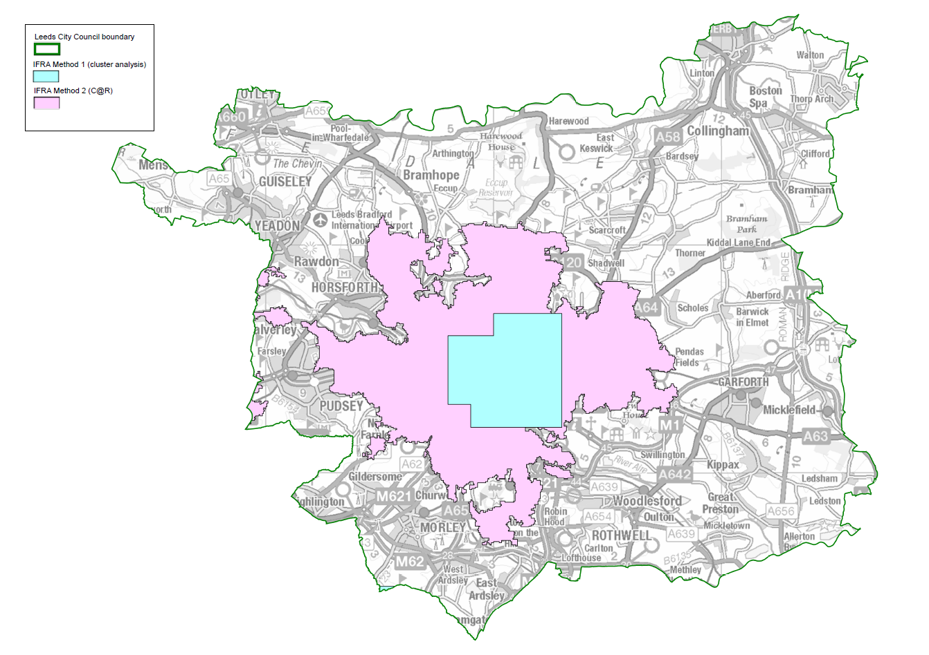

Flood Risk Areas identified through catchment based approach
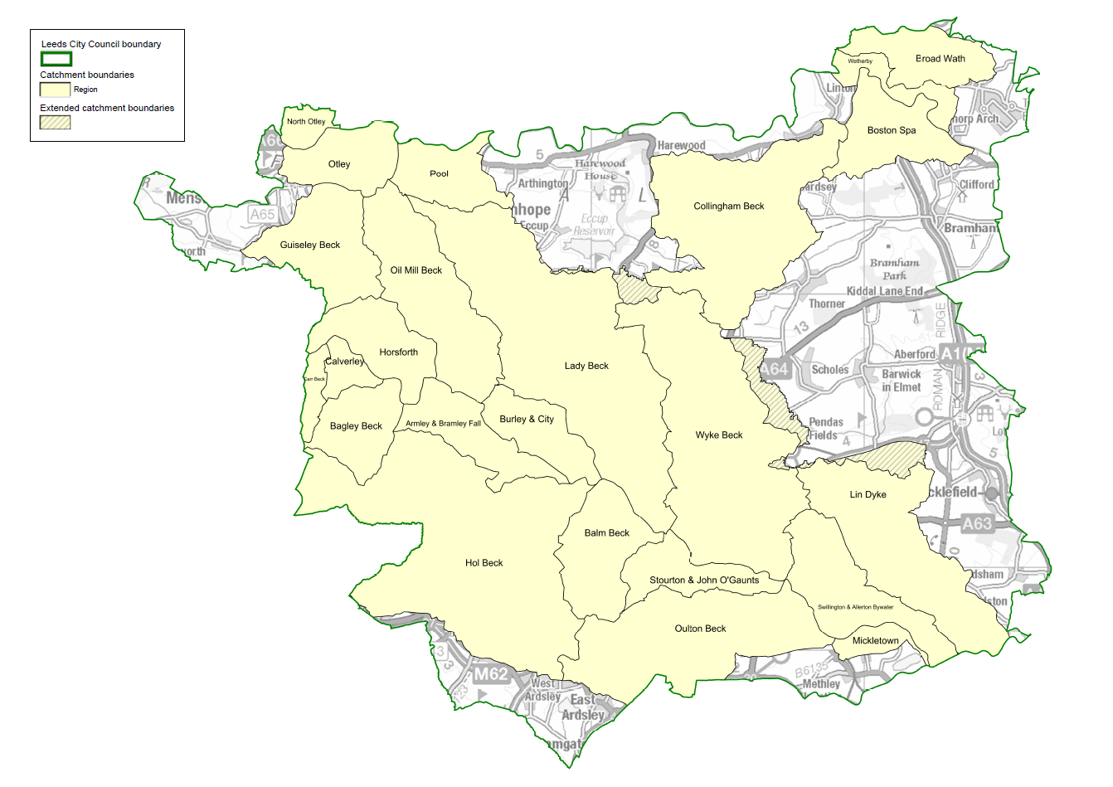
Comparison between Indicative Flood Risk Areas and Leeds Flood Risk Area
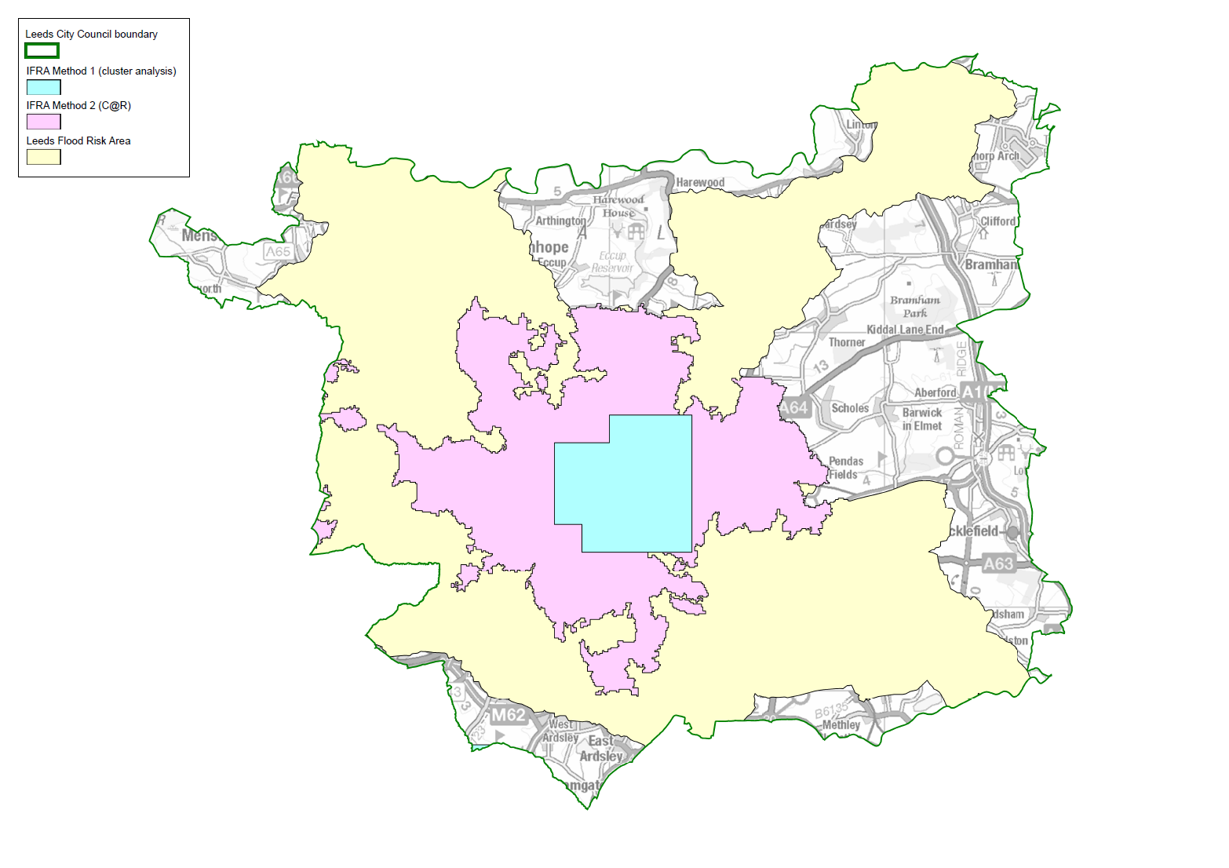

Leeds Flood Risk Area
