Annual Mental Health Minimum Data Set (MHMDS)
2009/10 Analysis.

27/01/11
Simeon Smith
Graduate Informatics Management Trainee
Information Analyst

Contents:

Executive Summary p3

Report
- Introduction p4
- Data Adjustment p4
- Care Spells p5
- Demographics p5
- Care Spell Activity p11
- PCT Activity p20
- CPA p21
- Diagnostics p24
- Conclusion p29

Executive Summary:

- The Mental Health Minimum Data Set (MHMDS) is yearly activity and demographic submission from the Trust to the NHS Information Centre. This report uses the 2009/10 MHMDS to investigate the characteristics of our service user population and the care they receive.
- LPFT provided 19,576 spells of specialist mental health care to 18,331 service users in 2009/10, a 16.5% increase on last year.
- This represents an access rate of roughly 24 care spells per 1,000 population of Leeds
- Ethnicity Equity Issues:
  - BME groups accounted for 9.8% of Trust care spells. However, BME groups accounted for 17.2% of inpatient care spells, suggesting a BME over representation in inpatient Care.
  - There was variation in contact rate and the distribution of contacts among different ethnicities. For example, Mixed Ethnicity care spells averaged at 1 contact in 15 days, whereas Asian or Asian British averaged at 1 contact in 22 days.
  - BME care spells are more likely to be on CPA.
- Gender Equity Issues:
  - There was significant male under-representation in access to Occupational Therapists and Consultant Psychotherapists (almost 10% less than expected). It may be that male service users are unable to access these services or feel discouraged from doing so.
- Data Completeness Issues
  - Data completeness for employment status and housing status was still a significant problem for the Trust in 2009/10.
- Data Completeness Improvements:
  - Overall, there was improvement in data completeness across the MHMDS from last year, especially for demographic measures.
- Next years analysis:
  - Next years analysis will be highly useful to the Trust with use of the census to compare the profile of our service users to the greater Leeds population and improvements to the MHMDS increasing its accuracy in portraying Trust activity.

- Introduction

This report profiles the Trust’s service users during the financial year 2009/10 based on the Mental Health Minimum Data Set (MHMDS) submission to the NHS Information Centre. It aims to investigate the characteristics of our service user population and the care they receive. This is the second year such an analysis has been done. Alongside basic demographics, emphasis will be placed on activity measures, the care programme approach and diagnostics.

The MHMDS is derived from all the activity data collected in the Trust on the Patient Record Administration System (PARIS), aggregated into care spells. A care spell in the MHMDS is taken as ‘a period of specialist mental healthcare in the Trust during which the service user may receive different types of care, including inpatient, crisis resolution and from a community mental health team.’ It commences with referral and terminates with discharge. The MHMDS is only as accurate and representative of the data as inputted into PARIS by Trust staff.

Due to a lack of clarity to whether Liaison Psychiatry was in the scope of the MHMDS, its data was not submitted to the Information Centre for this year. Additionally, the scope of the MHMDS does not include services provided by Learning Disabilities or Leeds Addiction Unit.

- Data Adjustment

The MHMDS was returned with a total of 22,253 care spells. The MHMDS automatically ends care spells if there is no activity for six months and there is no explicit discharge. Care spells with no activity in the six months preceding the reporting period or in the reporting period itself but with an explicit discharge in the reporting period suggests that the discharge should have been completed prior to the reporting period. 2,677 such care spells have been removed from the analysis to align them with the MHMDS automatic care spell ending process.

This report therefore assumes a total of 19,576 care spells in the 2009/10 reporting period.

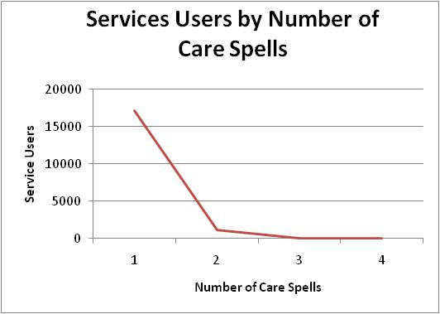
3. Care Spells
The Trust provided 19,576 spells of specialist mental health care during 2009/10 to 18,331 service users. Notable are a 16.5% increase in care spells and a 15.1% increase in service users compared with last year (2008/9: 16,795 care spells to 15,933 service users). This could be due to bringing more services onto PARIS and improved overall recording. Only 6.4% of service users had more than one care spell in the reporting period, as shown below.

Number of Spells | 1 | 2 | 3 | 4
Services Users | 17163 | 1092 | 75 | 1
Figure & Table 3: Service Users by Number of Care Spells within Reporting Period.

4. Demographics

a) Gender
In the reporting period females comprised the majority (58%) of the total care spells, roughly the same proportion as last year (2008/9: 57%). Notable is the decrease in the proportion of care spells with unknown genders from 0.9% last year to 0.2% reflecting an improvement in data completeness.

Figure 4a: Care Spells by Gender of Service User (See Appendix 4a)
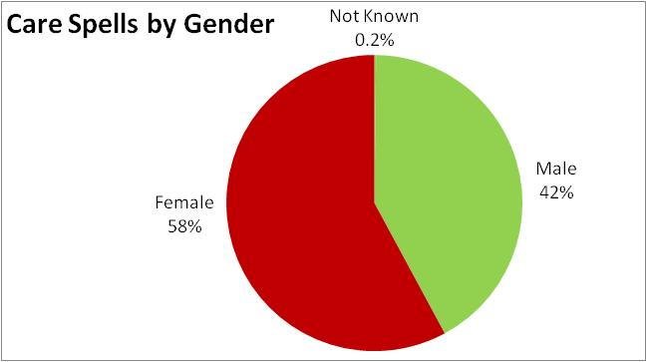

b) Age
Gender | Mean Age
Male | 50.5
Female | 56.0
Not Known | 34.5
Female service users were on average 5.5 years older than males on commencing their care spell. Across genders, the mean age was 53.6 years at care spell commencement.

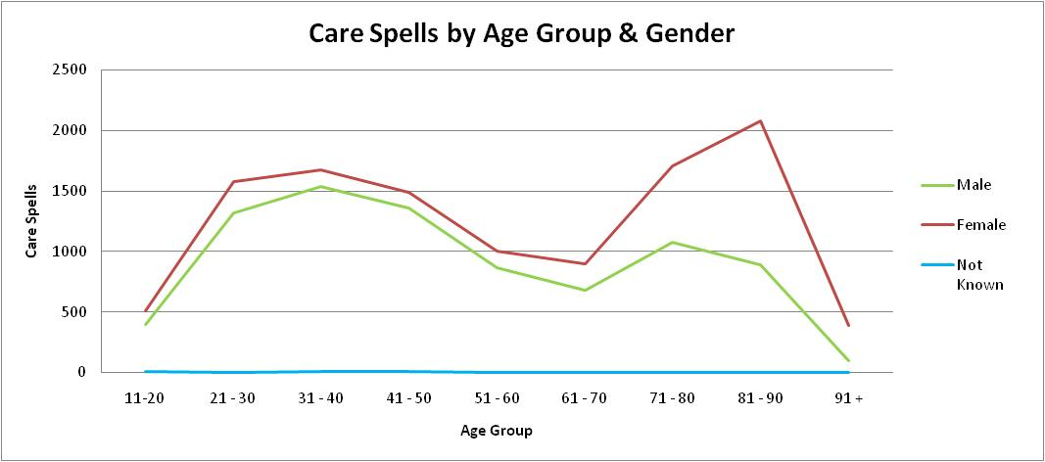
Figure 4b: Number of Care Spells by Age Range & Gender (See appendix 4b)

There are more female than male care spells across all age groups. Both male and female care spells show an initial peak at 31-40 years. This may reflect the higher frequency onset of mental health problems in young adulthood. For males, a second peak occurs at 71-80 years, yet this is lower than the first peak and decreases rapidly towards later age groups, possibly reflecting lower male life expectancy. For females, the second peak at 81-90 years is the highest care spell level; care spells at age 65 and over account for 43% of total female care spells. This may reflect the increasing prevalence of age related dementia for older people as life expectancies increase.

c) Ethnic Profile
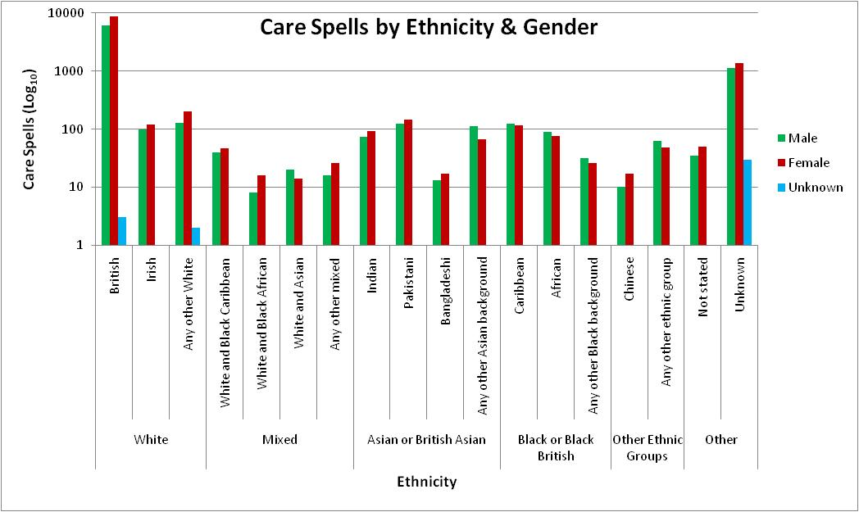
Figure 4c: Care Spells by Ethnicity and Gender (see Appendix 4c) NOTE LOG SCALE

12.8% of care spells had ‘unknown’ service user ethnicity, a decrease from last year (2008/9: 20%) 0.4% of care spells have a ‘not stated’ ethnicity, a substantial decrease from last year (2008/9: 12.4%). 76.7% of care spells were classed as having ‘White – British’ ethnicity, with ‘White-British’ Females accounting for 45.5% of total care spells.

In general, female tend to outnumber male care spells. However, it is worth noting that for all ‘Black or Black British’ care spells, males outnumber females. For the total of ‘Black or Black British’ ethnicities, there was 1.12 times more male than female care spells.

In comparison with last years, gender distributions across ethnicities are more balanced. For ‘Mixed- White & Asian’ care spells, there was 1.43 more males than female care spells (2008/09: 3 times more). For ‘Any Other Asian’ care spells, there was 1.72 times more male than female (2008/09: 1.72 times more).

The most current available measurements on the ethnic profile of Leeds is the 2001 Census, therefore it is not possible to confidently measure ethnic representation of the greater population in our services. The next census is in 2011.

d) Civil Status
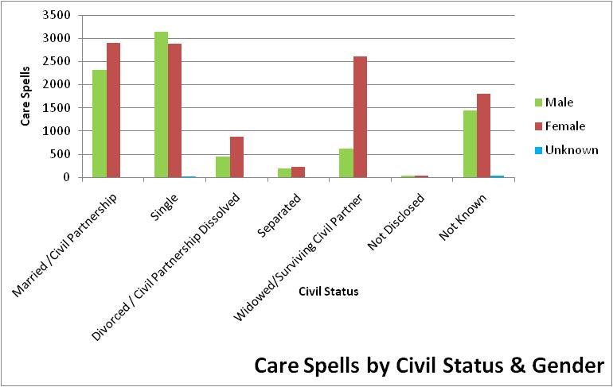

Figure 4d: Care Spells by Civil Status & Gender (see appendix 4d)

16.9% of Care Spells were recorded as having ‘Not Disclosed’ or ‘Not Known’ civil status, a considerable drop from last years level (2008/9: 53.8%). As with last year, ‘Single’ is the only category in which males out number females. For the ‘Widowed / Surviving Civil Partner’ category, women outnumber men by over 4 to 1, reflecting lower male life expectancies.

- Geography (see appendix 4e)
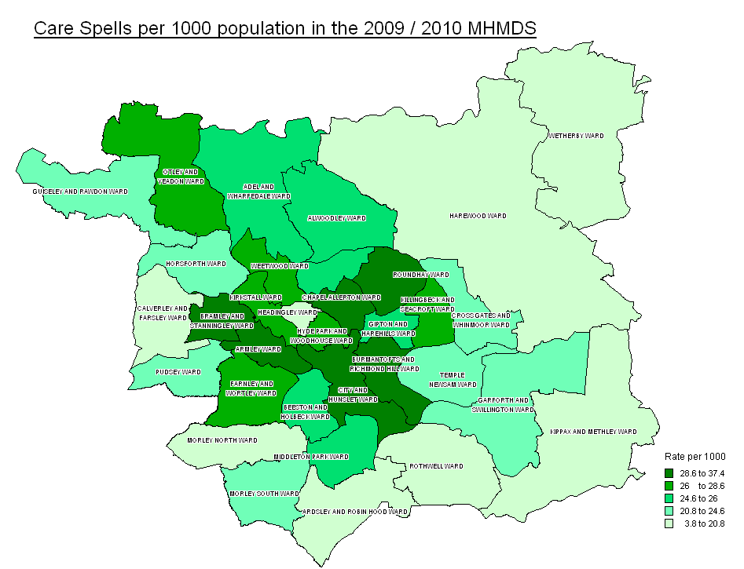

This map of Leeds shows the care spells per 1,000 population across the electoral wards of Leeds. (NB: Electoral ward population comes from ONS estimates of mid- 2007 population for 2009 wards.)

The highest rate was Armley, with 44 spells per 1,000 people. The lowest rate was in Wetherby with 6 spells per 1,000 people. However, care spells per population does not necessarily correlate with socioeconomics, as shown by the high rate in the Roundhay ward (33 spells per 1,000 people) possibly due to its older population (mean service user age: 61.5 years).

Geographic proximity may be having an impact on service user numbers, for example with Wetherby GPs choosing to refer to North Yorkshire and York PCT mental health services in Harrogate.

- Employment Status (Working Age)

The following pie chart displays employment status for care spells of service users of age 69 and under. The proportion of care spells with ‘not known’ employment status has decreased from 77% (2008/9) to 52%, reflected in an increase in ‘employed’ (2008/9: 3%) and ‘other employment’ (2009/9: 10%). Though an improvement, there is still a significant issue in data completeness for employment status.

Figure 4f: Care Spells by Employment Status, Age 69 and Under (see appendix 4f)
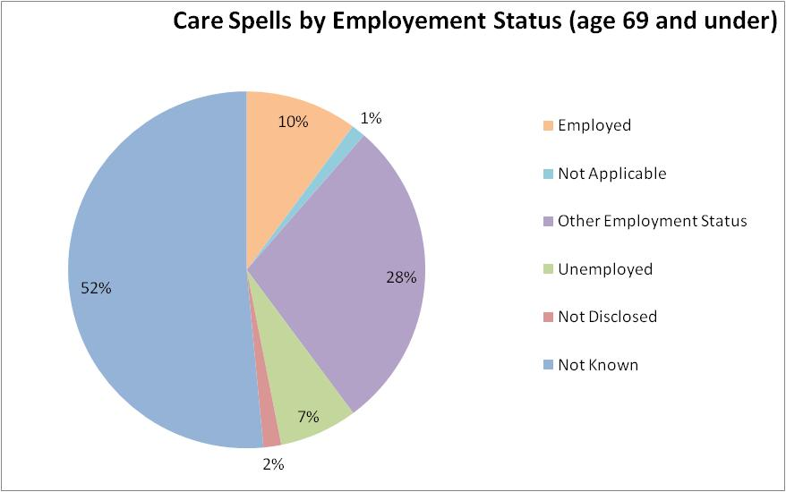

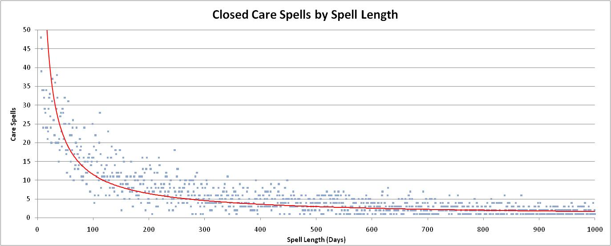
- Care Spell Activity
Figure 5ai: Scatter graph of Care Spell Frequency for Spell Length
Closed Care Spell Length
(days)
Mean | 421
Median | 196
Mode | 1
- Care Spell Length
Of the 19,576 Care Spells that were ongoing at some point in the reporting period, 45% (8,774) were recorded as closed within the reporting period. 16.5% (1,227) of these Care Spells closed within the reporting period had a length of 0 days (referrals seen and closed on the same day); these were removed to avoid distortion. The above scatter graph illustrates the distribution of the 6,567 care spells closed within the reporting period with spell length of 1 to 1,000 days. 13.1% (980) of care spells closed within in the reporting period had lengths above 1,000 days, with a maximum of 7,515 days.

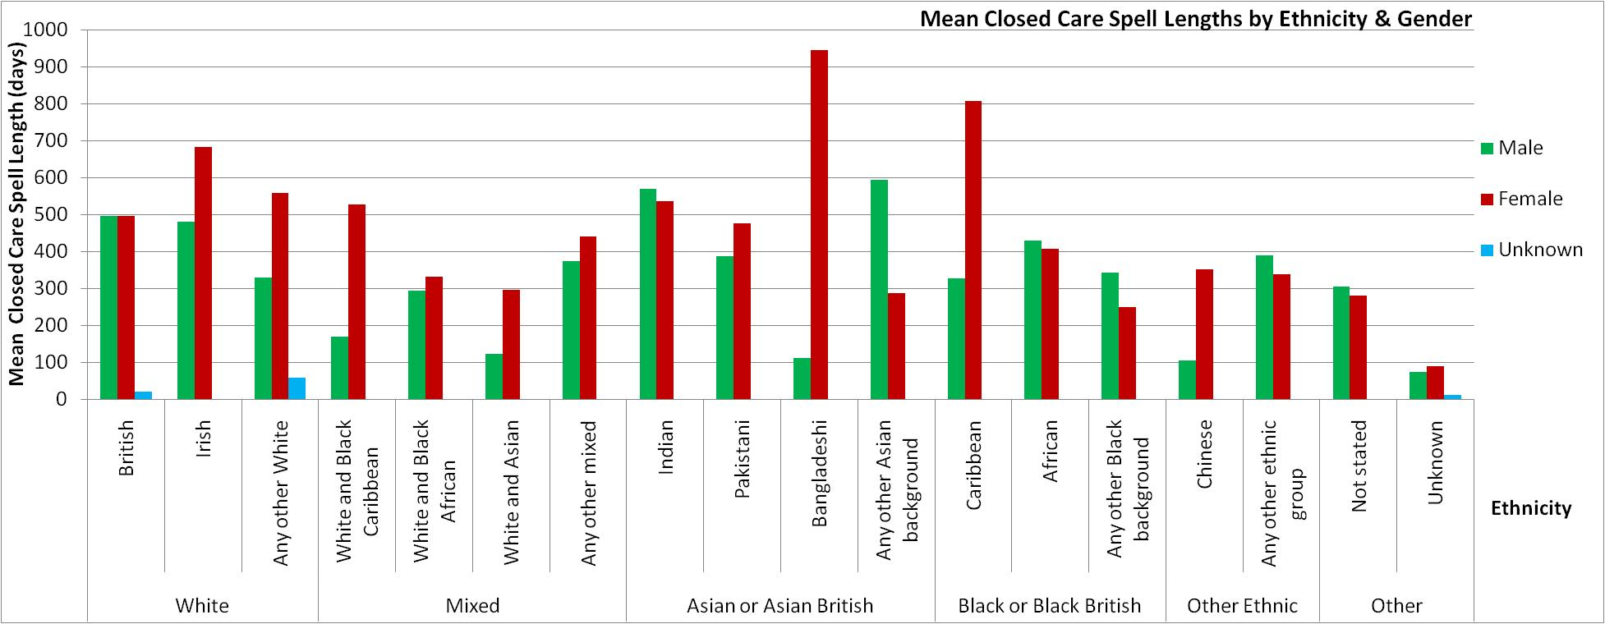

Figure 5aii: Mean Closed Care Spell Lengths by Ethnicity & Gender (see appendix 5a)

The large variation between female and male mean closed spell lengths for Bangladeshis and Chinese may be due to a small number of service users from these ethnicities (9 and 10 service users respectively). For all Asian or Asian British ethnicities together, male care spells care spells are on average 1.3% longer than female closed care spells.

Increased female closed care spell lengths for White Irish, ‘Any other white,’ and Black Caribbean service users may warrant further investigation (88, 129 & 71 service users respectively).

- Spell Days in Reporting Period

 | Spell Days in Reporting Period
Mean | 205 (2008/9: 186)
Median | 209
To analyse activity distribution within the reporting period, the number of days within the reporting period for each care spell are examined below. There were over 4 million spell days in the reporting period across the 19,576 care spells. BME appear to have more spell days in the reporting period than white ethnicities.

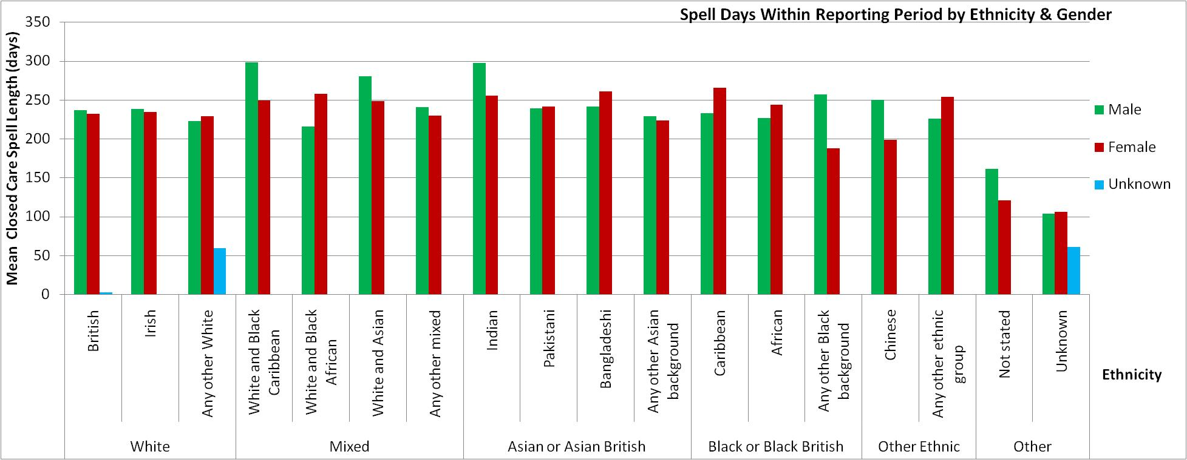
Figure 5b: Mean Spell Days within Reporting Period by Ethnicity & Gender (see appendix 5b)
 | Bed Days
Mean | 80.5
Median | 44
- Bed Days in Reporting Period
There were 1,622 Care Spells (8.3% of total) which received bed days during the reporting period.
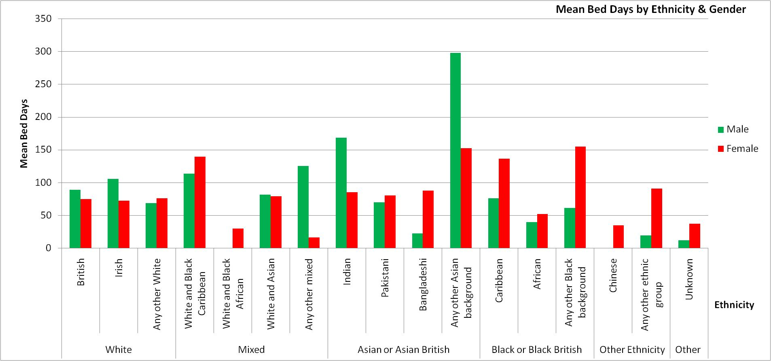
Of these 121 (0.62% of total) included PICU bed days.
Figure 5c: Mean Bed Days in Reporting Period by Gender & Ethnicity (see appendix 5c)

 | Contacts
Mean | 11.1 (2008/9:10.8)
Median | 5
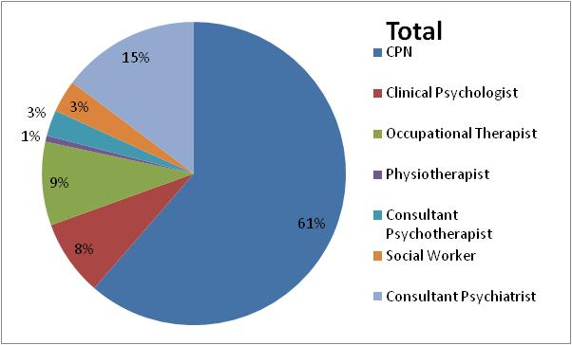
d) Contacts

i) Total

There were a total 18,227contacts across 16,539 care spells.
The majority of contacts with service users in the reporting period were through Community Psychiatric Nurses (61%); this proportion increased from last year (2008/09: 53%).

Figure 5di: Contacts distribution across all care spells, see appendix 5di)

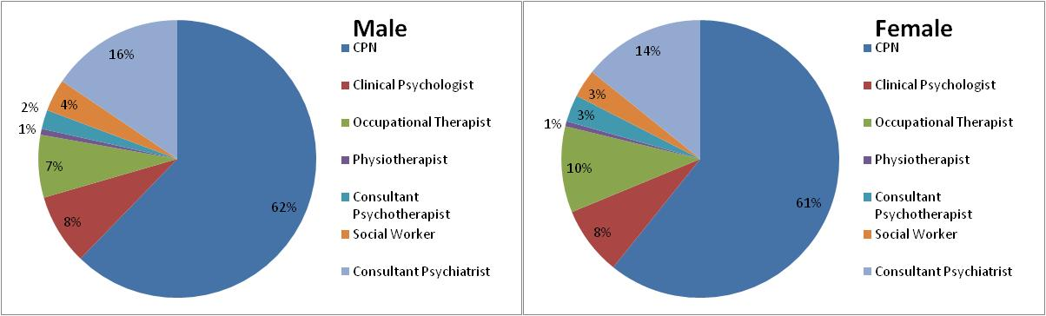
ii) By Gender (figure 5dii: Contact Distribution across male and female care spells, see appendix 5d)

Proportional distribution of contacts types between genders seems to be roughly equal.

iii) Gender Representation by Contact Type
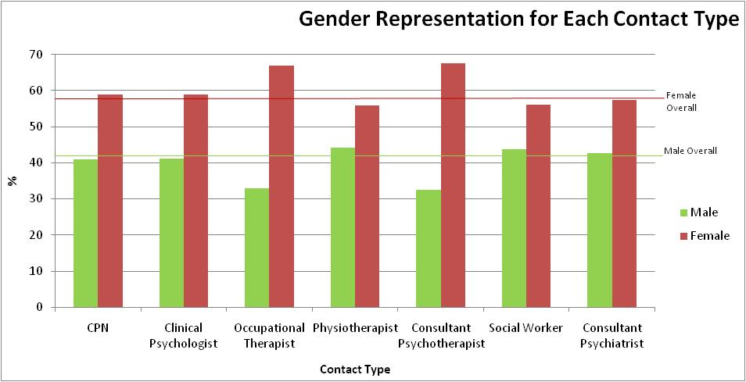
Figure 5diii: Gender Representation for each contact type (see appendix 5di ii)

As expected, due to overall female (~58%) to male (~42%) care spell representation, females have a greater contribution to the total number of contacts in each contact type.

Last year it was noted that for all contact types apart from ‘Social Worker’ and ‘Consultant Psychiatrist,’ female care spells were over-represented when compared to the gender profile of the data set. However, this may have been within accepted variation.

For this year’s analysis, it will be concluded that all contact types are broadly representative of the overall gender profile, apart from ‘Occupational Therapist’ (9% deviation) and ‘Consultant Psychotherapist’ (10% deviation) in which female care spells were over represented. This highlights potential equity issues for the Trust, as it may indicate that male service users are unable to access these services as well as female service, or feel discouraged from doing so. However, it may be that these services are more suited to female rehabilitation requirements or are required for treatment of mental health issues with higher female prevalence.

iv) By Ethnicity (Figure 5div: Proportional Distribution of Contacts by Ethnic Group, see appendix 5div)

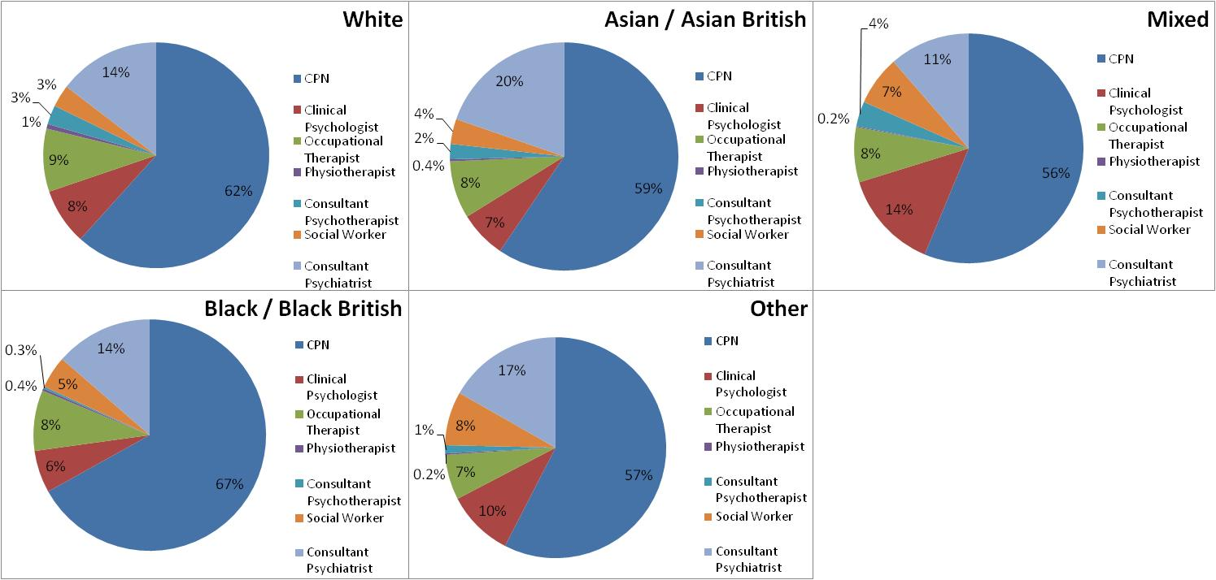

Differences in proportional distribution of contact types between ethnic groups may highlight potential equity issues for the Trust or indicate differing needs of ethnic groups.

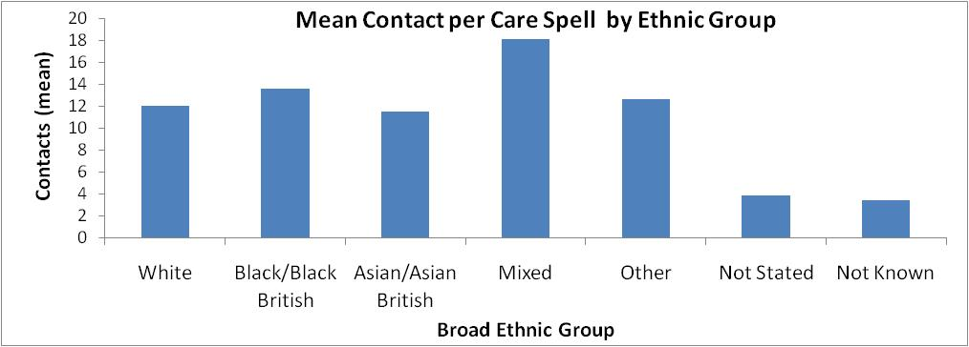
The Ethnic Group with the highest mean number of contacts was ‘Mixed’; contrastingly this ethnicity made the least proportional contacts with Consultant Psychiatrists (11%) and CPNs (56%).

Figure 5dv: Mean contacts per care spell by broad ethnic group (see appendix 5div)

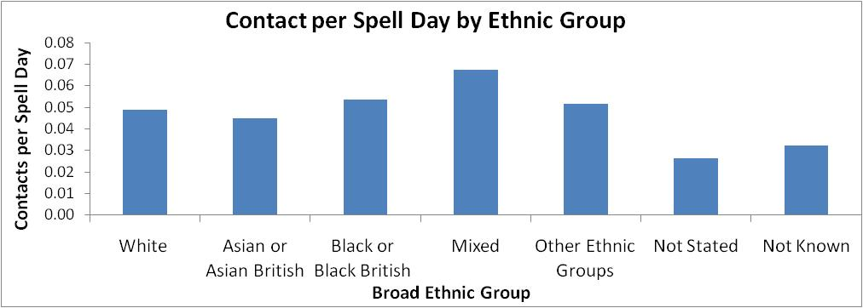

It is also worth noting that Asian or Asian British Care Spells have the lowest contact rate at 1 in 22 days compared to the highest at 1 in 15 days for Mixed Ethnicities.

Figure 5dvi: Mean Contacts per Spell Day by Broad Ethnic Group (see appendix 5div)
e) Activity by Age

Age | Under 70 |  |  |  | 70 and Over
 | Closed Care  Spell Length (days) | Spell Days in  Reporting Period | Bed Days | Contacts | Closed Care  Spell Length (days) | Spell Days in  Reporting Period | Bed Days | Contacts
Total  (care spells) | 2,110,069  (4,985) | 2,752,691  (13,149) | 103,197  (1,316) | 125,847  (11,149) | 1,065,585  (2,562) | 1,258,620  (6,427) | 27,462  (306) | 56,380  (5,210)
Mean | 423 | 209 | 78 | 11 | 399 | 196 | 90 | 11
Median | 176 | 219 | 39 | 5 | 232 | 188 | 63 | 4
Figure 5e: Table of Activity Measures by Age Group.

The above table shows the service users age 70 or over tend to have shorter care spell lengths, more bed days (if required), and an equal level of contacts as service users under the age of 70. This would suggest that care spells for the 70 and over are more intensive. 4.8% of care spells for those 70 and over had bed days relative to 10% of those aged under 70.

6) PCT Activity in Reporting Period
PCT | Care Spells | % | Spell Days | % | Bed Days | % | Contacts | %
NHS Leeds | 18784 | 96.0 | 3870986 | 96.5 | 121343 | 92.9 | 176946 | 97.1
Non-Leeds PCTs | 740 | 3.8 | 133148 | 3.3 | 8245 | 6.3 | 4995 | 2.7
Not Known | 52 | 0.3 | 7177 | 0.2 | 1071 | 0.8 | 286 | 0.2
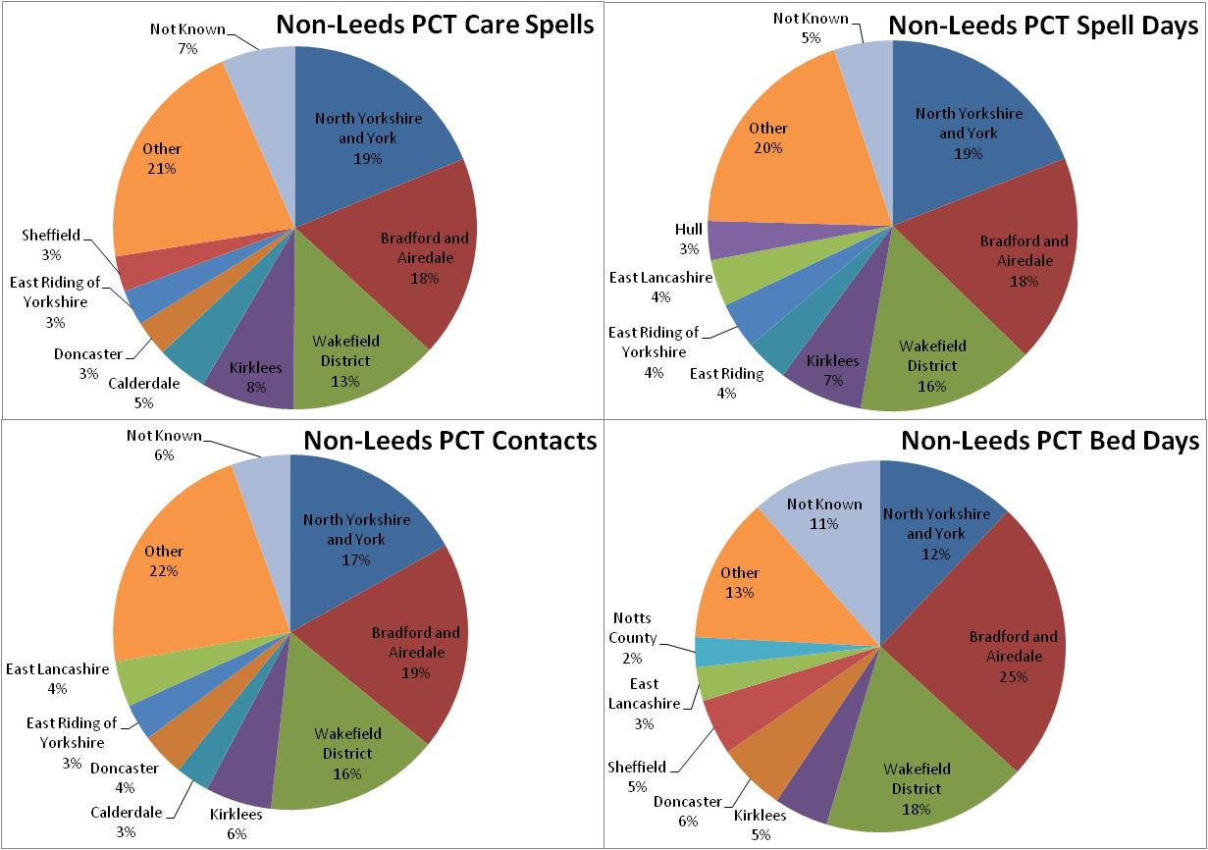
Table 6: Activity Breakdown between NHS Leeds and Other PCTs

In the last reporting period, care spells were commissioned by 69 different PCTs. The above table shows how the vast majority of Trust activity is commissioned by NHS Leeds. This breakdown is roughly equivalent to last year (NHS Leeds Spell Days: 96.2%, Bed Days: 80.56%, Contacts: 96.8%). Below is a breakdown of the Trust’s Out of Area commissioned activity, showing that over half the Trust’s non-Leeds PCTs commissioned activity comes from 3 PCTs (North Yorkshire and York, Bradford and Airedale and Wakefield).

Figure 6: Pie charts of
Non- Leeds PCTs’ Activity
(see appendix 6)

Note: Each pie displays
top 8 PCTs, Other and Unknown
for each Activity.

7) Care Programme Approach
(Note: The below analysis is based on the CPA level on the 31 March 2010).

a) Activity by CPA level
47% of care spells did not have a specified CPA level at the end reporting period. Activities follow much the same pattern as last year.
Figure 7a: Care Spells by CPA Level & Activity Means by CPA Level (see appendix 7a)
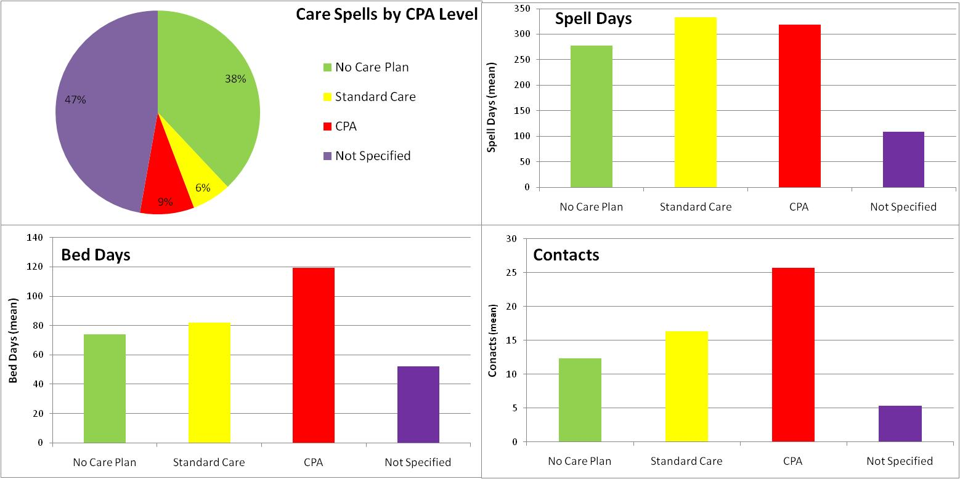
Bed Days: For the 1662 care spells with bed days, there is a clear rise in the mean number of bed days per care spell with increasing CPA level.
Contacts: For the 16359 care spells with contacts, there is a clear rise in the mean number of contacts per care spell with increasing CPA level.

Note: ‘No Care Plan’ can refer to 2 types of care spell:
1) Where an evaluation was carried out and no care plan was deemed necessary, or
2) Where a service user was discharged before the end of the reporting period.

b) CPA Level by Ethnicity:
There were 10340 care spells with a CPA evaluation (52.8% of total).
The below figure displays these by broad ethnic group.
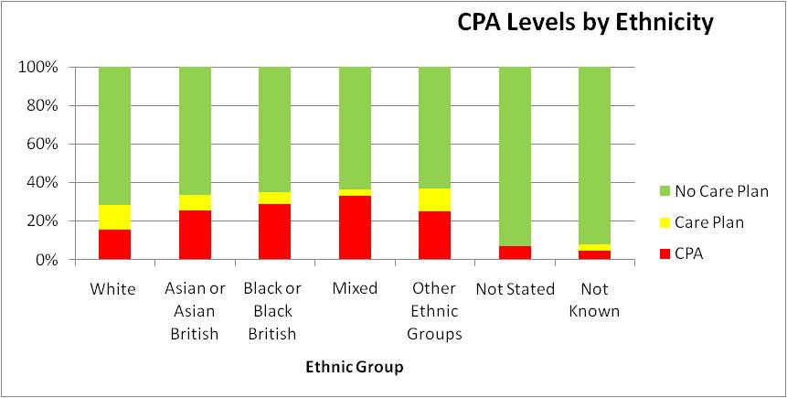
Figure 7b: Stacked Bar Chart of CPA Level Distribution by Ethnicity (see appendix 7b)
Care Spells of service users with mixed race have the highest proportion of New CPA, a reflection of mixed race care spells having the highest mean number of contacts (see 4biii). The lowest proportion of New CPA care spells is for ‘white’ ethnicity. As with last year, this may reflect a higher BME tendency to receive new CPA, indicating potential equity issues for the Trust.

c) CPA Level by Gender
Figure 7c: Pie Charts of CPA Level by Gender (see appendix 7c)

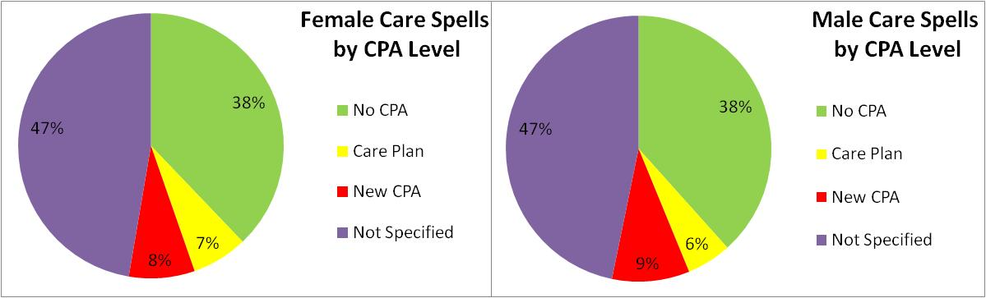

As can be seen above, the distribution of CPA Levels between genders is roughly equivalent.

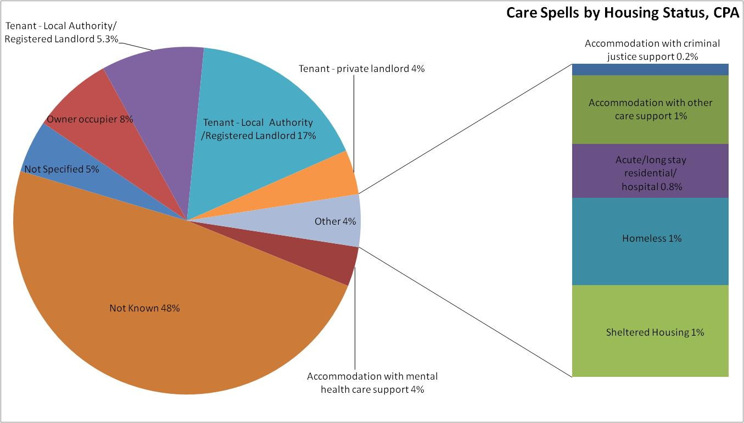
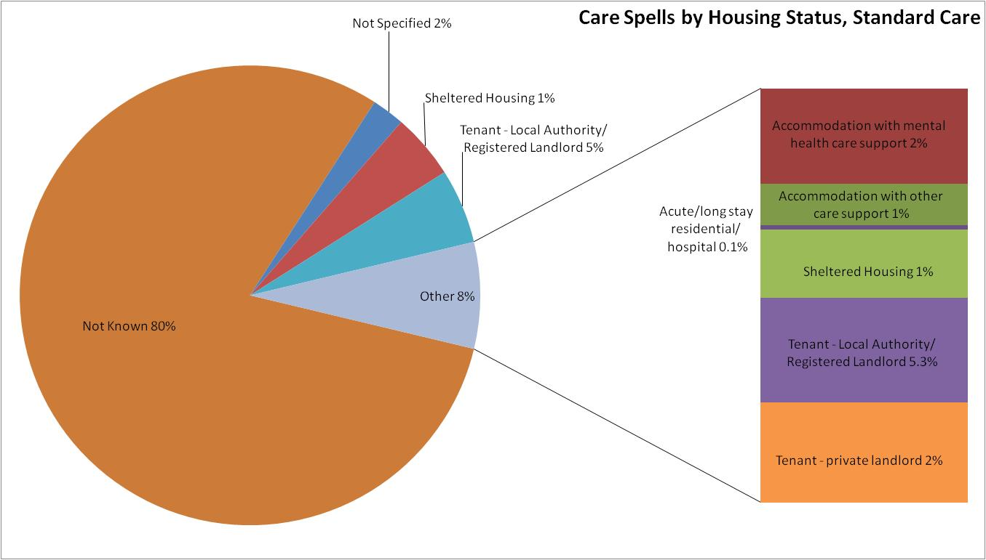
d) Accommodation Status by Care Plan Level: Accommodation status is only submitted to the mental health minimum data set for care spells in which service users receive a CPA evaluation resulting in a standard care plan, CPA or discharge (no Care Plan).
Figure 7d Accommodation Status by CPA Level (see appendix 7d)
The proportion of care spells with Not Known accommodation status is markedly higher for Standard Care than CPA level of care plan. This might be due to CPA functioning to support more intensive service user care; staff may perceive recording accommodation status as more relevant. However this still leaves 48% of CPA level care spells having unknown housing status, highlighting significant data completeness issue.

8) Diagnostics- ICD10

Note: Diagnostic Data is collected for Inpatients Only
The following is based on primary diagnoses only, therefore does not include further diagnoses or co-morbidities.
Included diagnoses are ‘Mental and Behavioural Disorders’ (F00-F99), Alzheimer’s Disease (G30), Holiday Relief Care (Z75.5) and other.

- Profile
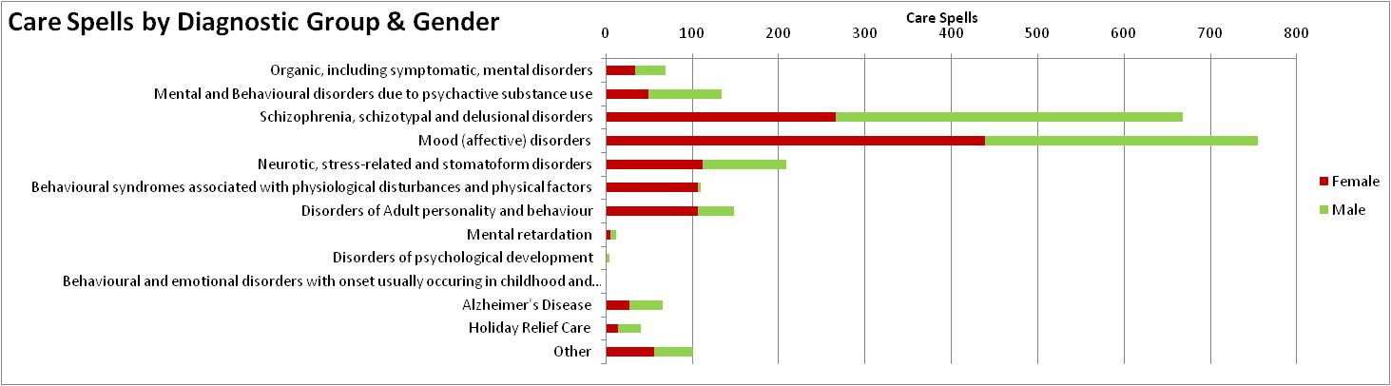
Figure 8a: Inpatient Care Spells by ICD 10 Diagnostic Group & Gender (see appendix 8a)

There were 2317 inpatient care spells coded for during the reporting period using ICD10. At a diagnostic group level, mood (affective) disorders and schizophrenia, schizotypal and delusional disorders represent 61.4% of inpatient care spells (2008/9: 50%). It is interesting to note that males represent 48% of in patient care spells compared to 42% of total Trust care spells.

- By CPA Level at End of Reporting Period
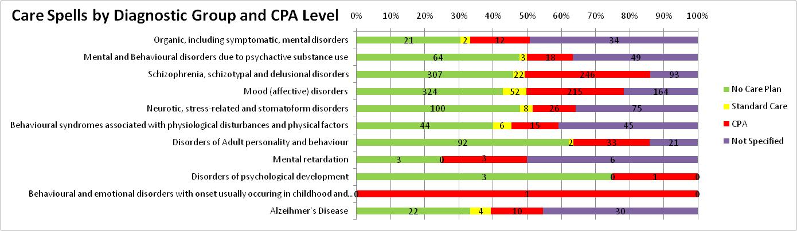
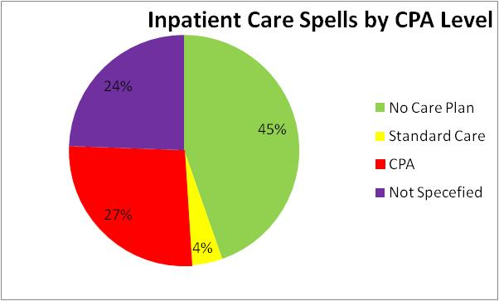
Figure 8b: Inpatient Care Spells by ICD10 Diagnostic group & CPA Level (see appendix 8b)

Note: Inpatient care spells with ‘no care plan’ may have been discharged before the end of the reporting period.

As would be expected, fewer inpatient care spells are on standard care and more are on CPA relative to the Trust as a whole.

- By Ethnicity
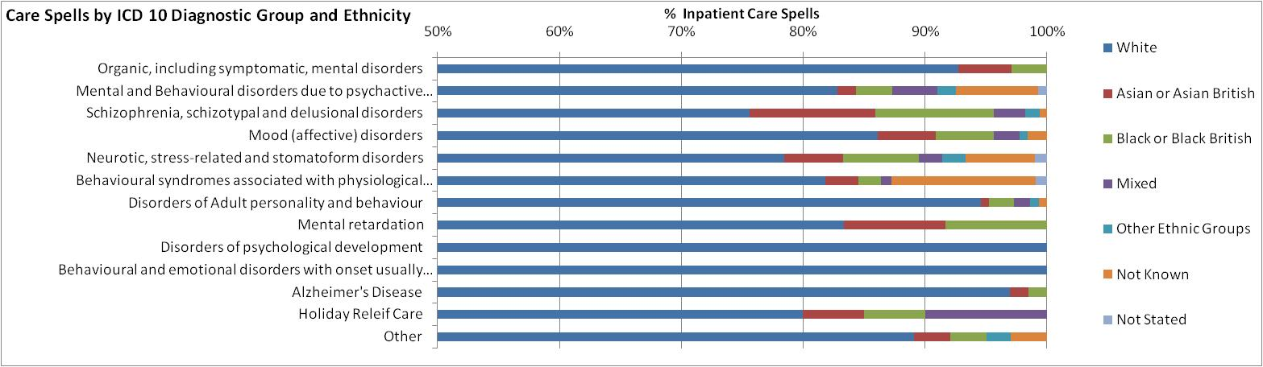
Figure 8c: Inpatient Care Spells by ICD10 Diagnostic Group & Ethnicity (see appendix 8c)

Note: Scale begins at 50%
It is not possible to draw firm conclusions about BME over representation for inpatient services without a recent and reliable estimate of the ethnic demographic profile of Leeds. However, excluding holiday relief care, BME groups account for 17.2% of in patient care spells. This compared with the BME proportion of total care spells at 9.8% may suggest that there is over-representation of BME in our inpatient services. However, this may be due to inpatient care spells having higher ethnicity completeness (2.5% ‘not known’ or ‘not stated’) relative to the total care spells (13.2% ‘not known’ or ‘not
stated’).

- By Age
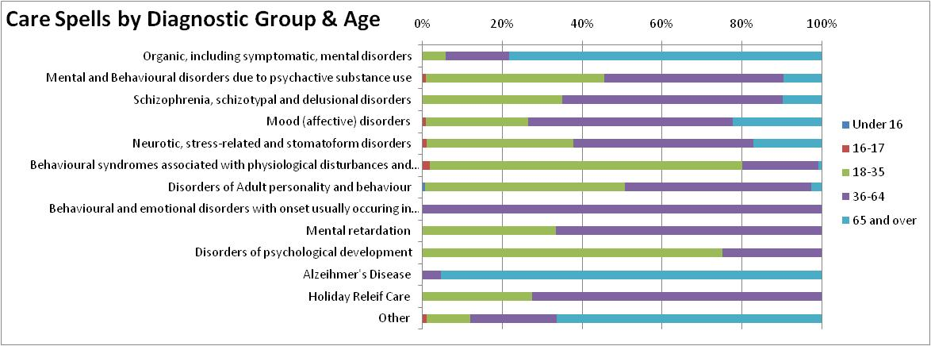
Figure 8d: Inpatient Care Spells by ICD10 Diagnostic Group & Age (see appendix 8d)

There are clear variations of age distribution of care spells between diagnostic groups. Notable is a 65 and over dominance of organic mental disorders and Alzheimer’s Disease.

- Top 20 ICD 10 codes (see appendix 8e)
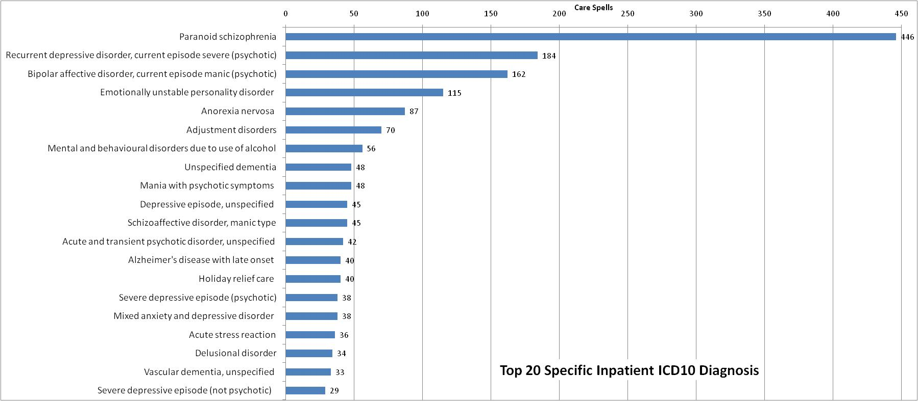
There were 159 different ICD10 Diagnostic Codes used for recording primary diagnoses of inpatient care spells during the reporting period. The above top 20 assigned diagnoses account for 70% of inpatient care spells. Paranoid schizophrenia alone accounts for 19% of inpatient care spells.

- Conclusion

This report has highlighted a dramatic improvement in data completeness, particularly for demographic elements of the MHMDS. Issues still remain, however, with the recording of housing information. The demographic breakdown of the service user population appears to be broadly the same as last year.

As with last year, , this analysis highlights potential equity issues for the Trust, for example an increased likelihood of BME care spells being on CPA and less male care spells accessing the service of occupational therapists and consultant psychotherapists given the care spell gender distribution.

Next years report may provide more insightful information on Trust service users as census data and mental health clustering will provide indication of demographic representation and care requirements respectively across our services.

Appendices
Appendix 4a: Care Spells by Gender (See Figure 4a)
Gender | Care Spells
Not Specified | 35
Male | 8211
Female | 11330
Total | 19576

Appendix 4b: Care Spells by Age Range & Gender (see Figure 4b)
 | Age Group
Gender | 11-20 | 21 - 30 | 31 - 40 | 41 - 50 | 51 - 60 | 61 - 70 | 71 - 80 | 81 - 90 | 91 + | Total
Male | 399 | 1315 | 1536 | 1360 | 864 | 679 | 1072 | 889 | 94 | 8208
Female | 513 | 1576 | 1674 | 1490 | 1004 | 896 | 1708 | 2080 | 388 | 11329
Unknown | 8 | 3 | 10 | 12 | 2 | 0 | 0 | 0 | 0 | 35
Total | 920 | 2894 | 3220 | 2862 | 1870 | 1575 | 2780 | 2969 | 482 | 19572

Appendix 4c: Care Spells by Ethnicity & Gender (See Figure 4c)
Ethnicity |  | Male | Female | Unknown | Total
White | British | 6103 | 8900 | 3 | 15006
 | Irish | 99 | 120 | 0 | 219
 | Any other White | 127 | 200 | 2 | 329
Mixed | White and Black Caribbean | 40 | 47 | 0 | 87
 | White and Black African | 8 | 16 | 0 | 24
 | White and Asian | 20 | 14 | 0 | 34
 | Any other mixed | 16 | 26 | 0 | 42
Asian or British Asian | Indian | 73 | 92 | 0 | 165
 | Pakistani | 123 | 146 | 0 | 269
 | Bangladeshi | 13 | 17 | 0 | 30
 | Any other Asian background | 114 | 66 | 0 | 180
Black or Black British | Caribbean | 122 | 115 | 0 | 237
 | African | 89 | 75 | 0 | 164
 | Any other Black background | 32 | 26 | 0 | 58
Other Ethnic Groups | Chinese | 10 | 17 | 0 | 27
 | Any other ethnic group | 63 | 49 | 0 | 112
Other | Not stated | 35 | 50 | 0 | 85
 | Unknown | 1124 | 1354 | 30 | 2508
 | Total | 8211 | 11330 | 35 | 19576

Appendix 4d: Care Spells by Civil Status & Gender (see figure 4d)
Marital Status | Total | Male | Female | Unknown
Married /Civil Partnership | 5214 | 2316 | 2898 | 0
Single | 6011 | 3133 | 2875 | 3
Divorced / Civil Partnership Dissolved | 1333 | 459 | 874 | 0
Separated | 418 | 197 | 221 | 0
Widowed/Surviving Civil Partner | 3229 | 622 | 2607 | 0
Not Disclosed | 83 | 36 | 47 | 0
Not Known | 3288 | 1448 | 1808 | 32
Total | 19576 | 8211 | 11330 | 35
Appendix 4e: Care Spells per 1000 Population of Leeds Electoral Wards 2007 (see Figure 4e)
Electoral Ward | Care Spells | Population | Care Spells per 1000 pop.
Adel and Wharfedale | 575 | 20,701 | 27.78
Alwoodley | 679 | 23,403 | 29.01
Ardsley and Robin Hood | 390 | 22,029 | 17.70
Armley | 1155 | 26,120 | 44.22
Beeston and Holbeck | 674 | 23,302 | 28.92
Bramley and Stanningley | 742 | 23,110 | 32.11
Burmantofts and Richmond Hill | 875 | 24,588 | 35.59
Calverley and Farsley | 510 | 22,105 | 23.07
Chapel Allerton | 804 | 22,795 | 35.27
City and Hunslet | 931 | 25,133 | 37.04
Cross Gates and Whinmoor | 611 | 22,806 | 26.79
Farnley and Wortley | 749 | 24,172 | 30.99
Garforth and Swillington | 566 | 20,773 | 27.25
Gipton and Harehills | 762 | 27,274 | 27.94
Guiseley and Rawdon | 566 | 22,542 | 25.11
Harewood | 263 | 18,510 | 14.21
Headingley | 429 | 22,846 | 18.78
Horsforth | 531 | 22,220 | 23.90
Hyde Park and Woodhouse | 847 | 28,062 | 30.18
Killingbeck and Seacroft | 760 | 24,658 | 30.82
Kippax and Methley | 424 | 21,169 | 20.03
Kirkstall | 693 | 22,742 | 30.47
Middleton Park | 744 | 25,901 | 28.72
Moortown | 667 | 23,164 | 28.79
Morley North | 492 | 23,374 | 21.05
Morley South | 597 | 21,921 | 27.23
Otley and Yeadon | 712 | 23,253 | 30.62
Pudsey | 582 | 22,367 | 26.02
Rothwell | 469 | 20,865 | 22.48
Roundhay | 777 | 23,859 | 32.57
Temple Newsam | 591 | 22,645 | 26.10
Weetwood | 670 | 22,395 | 29.92
Wetherby | 118 | 20,320 | 5.81

Appendix 4f: Care Spells by Employment Status (see figure 4f)
 | Care Spells
Employment Status | All Ages | % | 69 and under | % | 70 and over | %
Employed | 1333 | 6.81 | 1331 | 10.12 | 2 | 0.03
Not Applicable | 3847 | 19.65 | 169 | 1.29 | 3678 | 57.23
Not Disclosed | 212 | 1.08 | 212 | 1.61 | 0 | 0.00
Not Known | 246 | 1.26 | 245 | 1.86 | 1 | 0.02
Other Employment Status | 3779 | 19.30 | 3737 | 28.42 | 42 | 0.65
Unemployed | 930 | 4.75 | 929 | 7.07 | 1 | 0.02
Not Recorded | 9229 | 47.14 | 6526 | 49.63 | 2703 | 42.06
Total | 19576 |  | 13149 |  | 6427

Appendix 5a: Mean Closed Care Spell Lengths by Ethnicity & Gender (see figure 5 aii)
 |  | Gender
Ethnic Class | Ethnic Group | Male | n | Female | n | Unknown | n
White | British | 496.4333 | 2091 | 497.85447 | 3154 | 22 | 1
 | Irish | 481.5476 | 42 | 684.23913 | 46
 | Any other White | 330.766 | 47 | 558.80282 | 71 | 58.5 | 2
Mixed | White and Black Caribbean | 169 | 5 | 527.77778 | 18
 | White and Black African | 295.1667 | 6 | 333.2 | 5
 | White and Asian | 124.3333 | 3 | 296.6 | 5
 | Any other mixed | 374.8 | 5 | 440.5 | 6
Asian or Asian British | Indian | 570.6316 | 19 | 537.48276 | 29
 | Pakistani | 387.4667 | 45 | 477.52083 | 48
 | Bangladeshi | 113 | 2 | 946.42857 | 7
 | Any other Asian background | 594.95 | 40 | 286.7619 | 21
Black or Black British | Caribbean | 328.1667 | 42 | 808.68966 | 29
 | African | 430.4 | 30 | 407.82609 | 23
 | Any other Black background | 343.3636 | 11 | 250.81818 | 11
Other Ethnic Groups | Chinese | 105.25 | 4 | 351.66667 | 6
 | Any other ethnic group | 391.1053 | 19 | 338.13333 | 15
Other | Not stated | 305.1905 | 21 | 280.17241 | 29
 | Unknown | 73.41476 | 709 | 90.967201 | 858 | 11.40909 | 22

Appendix 5b: Spell days in reporting period by ethnicity & gender (see figure 5b)
 |  | Male | Female | Unknown
White | British | 237 | 233 | 3
 | Irish | 239 | 235
 | Any other White | 223 | 229 | 60
Mixed | White and Black Caribbean | 298 | 249
 | White and Black African | 216 | 258
 | White and Asian | 281 | 249
 | Any other mixed | 241 | 230
Asian or Asian British | Indian | 298 | 256
 | Pakistani | 239 | 242
 | Bangladeshi | 241 | 261
 | Any other Asian background | 230 | 224
Black or Black British | Caribbean | 233 | 266
 | African | 227 | 244
 | Any other Black background | 257 | 188
Other Ethnic Group | Chinese | 250 | 199
 | Any other ethnic group | 226 | 254
Other | Not stated | 161 | 121
 | Unknown | 104 | 107 | 61

Appendix 5c: Mean Bed Days in Reporting Period (see figure 5c)
 | Gender
Ethnicity | Male | Female
White | 264 | 224
British | 89 | 75
Irish | 106 | 73
Any other White | 69 | 76
Mixed | 321 | 266
White and Black Caribbean | 114 | 140
White and Black African |  | 30
White and Asian | 82 | 79
Any other mixed | 126 | 17
Asian or Asian British | 560 | 406
Indian | 168 | 85
Pakistani | 70 | 81
Bangladeshi | 23 | 88
Any other Asian background | 298 | 152
Black or Black British | 178 | 344
Caribbean | 77 | 137
African | 40 | 52
Any other Black background | 62 | 155
Other Ethnicity | 19 | 126
Chinese |  | 35
Any other ethnic group | 19 | 91
Other | 12 | 37
Unknown | 12 | 37

Appendix 5d i/ii/iii: Care Spells by Gender & Contact Type (see figure 5di/ii/iii)
 | Contact
Gender | Total | CPN | Clinical Psychologist | Occupational Therapist | Physiotherapist | Consultant Psychotherapist | Social Worker | Consultant Psychiatrist
Male | 73683 | 45879 | 6074 | 5373 | 511 | 1637 | 2765 | 11444
Female | 108480 | 65916 | 8673 | 10884 | 647 | 3408 | 3532 | 15420
Not Known | 64 | 51 | 0 | 4 | 0 | 0 | 8 | 1
Total | 182227 | 111846 | 14747 | 16261 | 1158 | 5045 | 6305 | 26865

Appendix 5div: Care Spells by Ethnicity & Contact Type (see figure 5div)
 |  | Total Contacts | Care Spells | Contacts / Care spells | CPN | Clinical Psychologist | Occupational Therapist | Physiotherapist | Consultant Psychotherapist | Social Worker | Consultant Psychiatrist
Ethnic Class | White | 159727 | 13254 | 12.1 | 98544 | 12909 | 14417 | 1079 | 4368 | 5096 | 23314
 | Black/Black British | 5279 | 389 | 13.6 | 3533 | 311 | 446 | 17 | 15 | 239 | 718
 | Asian/Asian British | 6366 | 551 | 11.6 | 3787 | 425 | 519 | 19 | 137 | 226 | 1253
 | Mixed | 2991 | 165 | 18.1 | 1683 | 417 | 233 | 4 | 105 | 209 | 340
 | Other | 1421 | 112 | 12.7 | 818 | 139 | 94 | 3 | 17 | 112 | 238
 | Not Stated | 208 | 54 | 3.9 | 84 | 29 | 22 | 0 | 0 | 7 | 66
 | Not Known | 6235 | 1834 | 3.4 | 3397 | 517 | 530 | 36 | 403 | 416 | 936
 | Total | 182227 | 16359 |  | 111846 | 14747 | 16261 | 1158 | 5045 | 6305 | 26865

Appendix 6: Activity for Non-Leeds PCT commissioned Care Spells (see figure 6)
 | Activity (Sum)
Non-Leeds PCT | Care Spells | Spell Days | Bed Days | Contacts
North Yorkshire and York | 149 | 26724 | 1120 | 891
Bradford and Airedale | 142 | 25567 | 2309 | 1005
Wakefield District | 106 | 21757 | 1665 | 838
Kirklees | 66 | 10277 | 441 | 318
Calderdale | 36 | 5295 | 0 | 164
Doncaster | 25 | 3973 | 553 | 208
East Riding of Yorkshire | 25 | 5708 | 66 | 177
Sheffield | 25 | 2584 | 458 | 101
East Lancashire | 20 | 5726 | 272 | 219
Hull | 17 | 4801 | 102 | 148
Notts County | 5 | 396 | 245 | 34
Other | 166 | 27293 | 1182 | 1175
Not Known | 52 | 7177 | 1071 | 286

Note: This the 11 PCTs with the most activty out of 69 PCTs that commissioned Care Spells for LPFT during the reporting period.

Appendix 7a: Activity by CPA Level (see figure 7a)
Sum Care Spells, Sum Spell Days & Spell Day Rate by CPA Level
CPA Level | Care Spells | Spell Days | Spell Days/Care Spell
No Care Plan | 7442 | 2064951 | 277
Standard Care | 1217 | 405571 | 333
CPA | 1681 | 535947 | 319
Not Specified | 9236 | 1004842 | 109
Total | 19576 | 4011311

Sum Care Spells, Sum Bed Days & Bed Day Rate by CPA Level (care spells with 0 bed days removed)
CPA Level | Care Spells | Bed Days | Bed Days / Care Spell
No Care Plan | 793 | 58746 | 74
Standard Care | 56 | 4593 | 82
CPA | 402 | 47931 | 119
Not Specified | 371 | 19389 | 52
Total | 1622 | 130659

17974 Care Spells with 0 Bed Days Removed:
8865 Not Specified
6649 No Care Plan
1161 Standard Care
1279 CPA

Sum Care Spells, Sum Contacts and Contact Rate by CPA Level
(care spells with 0 contacts removed)
CPA Level | Care Spells | Contacts | Contact / Care Spells
No Care Plan | 6876 | 84717 | 12
Standard Care | 1203 | 19661 | 16
CPA | 1665 | 42832 | 26
Not Specified | 6615 | 35017 | 5
Total | 16359 | 182227

3217 Care Spells with 0 contacts removed:
2621 Not Specified
566 No Care Plan
14 Standard Care
16 CPA

Appendix 7b: Sum Care Spells by CPA level and Ethnicity (see figure 7b)
Ethnicity | Care Spells with CPA evaluation | No Care Plan | Care Plan | CPA | Not Evaluated
White | 8942 | 6387 | 1137 | 1418 | 6612
Asian or Asian British | 381 | 252 | 31 | 98 | 263
Black or Black British | 278 | 180 | 18 | 80 | 181
Mixed | 121 | 77 | 4 | 40 | 66
Other Ethnic Groups | 76 | 48 | 9 | 19 | 63
Not Stated | 14 | 13 | 0 | 1 | 71
Not Known | 528 | 485 | 18 | 25 | 1980
Totals | 10340 | 7442 | 1217 | 1681 | 9236

Appendix 7c: Sum Care Spells by CPA level and Gender (see figure 7d)
CPA Level | Female | Male | Not Known | Total
No CPA | 4290 | 3151 | 1 | 7442
Care Plan | 771 | 446 | 0 | 1217
New CPA | 908 | 773 | 0 | 1681
Not Evaluated | 5361 | 3841 | 34 | 9236
Total | 11330 | 8211 | 35 | 19576

Appendix 7d: Care Spells by CPA level and Accommodation Status
 | Care Plan Level
Housing Status | Care Plan | % |  | New CPA |  | % |  | Discharged | %
Accommodation with criminal justice support | 0 | 0.0 |  | 3 |  | 0.2 |  | 15 | 0.2
Accommodation with mental health care support | 21 | 1.7 |  | 62 |  | 3.7 |  | 130 | 1.7
Accommodation with other (not specialist mental health) care support | 9 | 0.7 |  | 18 |  | 1.1 |  | 61 | 0.8
Acute/long stay healthcare residential facility/hospital | 1 | 0.1 |  | 14 |  | 0.8 |  | 13 | 0.2
Homeless | 0 | 0.0 |  | 23 |  | 1.4 |  | 33 | 0.4
Not Known | 978 | 80.4 |  | 815 |  | 48.5 |  | 5884 | 79.1
Not Specified | 28 | 2.3 |  | 82 |  | 4.9 |  | 233 | 3.1
Owner occupier | 56 | 4.6 |  | 126 |  | 7.5 |  | 251 | 3.4
Sheltered Housing | 15 | 1.2 |  | 24 |  | 1.4 |  | 45 | 0.6
Tenant - Housing Association | 23 | 1.9 |  | 161 |  | 9.6 |  | 248 | 3.3
Tenant - Local Authority/Arms Length Management Organisation/Registered Landlord | 64 | 5.3 |  | 283 |  | 16.8 |  | 359 | 4.8
Tenant - private landlord | 22 | 1.8 |  | 70 |  | 4.2 |  | 170 | 2.3
Total | 1217 |  |  | 1681 |  |  |  | 7442

Appendix 8a: Care Spells by ICD 10 Diagnostic Groups & Gender
Diagnosis Code Group | Diagnosis | Care Spells | Male | Female
F00-F09 | Organic, including symptomatic, mental disorders | 69 | 35 | 34
F10-F19 | Mental and Behavioural disorders due to psychoactive substance use | 134 | 85 | 49
F20-F29 | Schizophrenia, schizotypal and delusional disorders | 668 | 402 | 266
F30-F39 | Mood (affective) disorders | 755 | 316 | 439
F40-F49 | Neurotic, stress-related and stomatoform disorders | 209 | 97 | 112
F50-F59 | Behavioural syndromes associated with physiological disturbances and physical factors | 110 | 4 | 106
F60-F69 | Disorders of Adult personality and behaviour | 148 | 42 | 106
F70-F79 | Mental retardation | 12 | 7 | 5
F80-F89 | Disorders of psychological development | 4 | 4
F90-F99 | Behavioural and emotional disorders with onset usually occuring in childhood and adolescence | 1 | 1
 | Holiday Releif Care | 40 | 26 | 14
 | Other | 167 | 83 | 84
 | Total | 2317 | 1103 | 1214

Appendix 8b: Care Spells by ICD 10 Diagnostic Group & CPA Level
Diagnosis Group | No CPA | Care Plan | New CPA | Not known
Organic, including symptomatic, mental disorders | 21 | 2 | 12 | 34
Mental and Behavioural disorders due to psychactive substance use | 64 | 3 | 18 | 49
Schizophrenia, schizotypal and delusional disorders | 307 | 22 | 246 | 93
Mood (affective) disorders | 324 | 52 | 215 | 164
Neurotic, stress-related and stomatoform disorders | 100 | 8 | 26 | 75
Behavioural syndromes associated with physiological disturbances and physical factors | 44 | 6 | 15 | 45
Disorders of Adult personality and behaviour | 92 | 2 | 33 | 21
Mental retardation | 3 | 0 | 3 | 6
Disorders of psychological development | 3 | 0 | 1 | 0
Behavioural and emotional disorders with onset usually occuring in childhood and adolescence | 0 | 0 | 1 | 0

Appendix 8c: Care Spells by ICD 10 Diagnosis Group & Ethnic Group
 | Ethnicity
Diagnostic Group | White | Asian or Asian British | Black or Black British | Mixed | Other Ethnic Groups | Not Stated | Not Known | Total
Organic, including symptomatic, mental disorders | 64 | 3 | 2 | 0 | 0 | 0 | 0 | 69
Mental and Behavioural disorders due to psychactive substance use | 111 | 2 | 4 | 5 | 2 | 1 | 9 | 134
Schizophrenia, schizotypal and delusional disorders | 505 | 69 | 65 | 17 | 8 | 0 | 4 | 668
Mood (affective) disorders | 650 | 36 | 36 | 16 | 5 |  | 12 | 755
Neurotic, stress-related and stomatoform disorders | 164 | 10 | 13 | 4 | 4 | 2 | 12 | 209
Behavioural syndromes associated with physiological disturbances and physical factors | 90 | 3 | 2 | 1 | 0 | 1 | 13 | 110
Disorders of Adult personality and behaviour | 140 | 1 | 3 | 2 | 1 | 0 | 1 | 148
Behavioural and emotional disorders with onset usually occurring in childhood and adolescence | 1 | 0 | 0 | 0 | 0 | 0 | 0 | 1
Mental retardation | 10 | 1 | 1 | 0 | 0 | 0 | 0 | 12
Disorders of psychological development | 4 | 0 | 0 | 0 | 0 | 0 | 0 | 4
Other | 154 | 4 | 4 |  | 2 |  | 3 | 167
Total | 1893 | 129 | 130 | 45 | 22 | 4 | 54 | 2277

Appendix 8d: Care Spells by ICD 10 Diagnosis Group & Age
Diagnosis Group | Care Spells | Average Age | Under 16 | 16-17 | 18-35 | 36-64 | 65 and over
Organic, including symptomatic, mental disorders | 69 | 73 | 0 | 0 | 4 | 11 | 54
Mental and Behavioural disorders due to psychactive substance use | 134 | 40 | 0 | 1 | 60 | 60 | 13
Schizophrenia, schizotypal and delusional disorders | 668 | 41 | 0 | 0 | 234 | 368 | 66
Mood (affective) disorders | 755 | 47 | 0 | 6 | 194 | 386 | 169
Neurotic, stress-related and stomatoform disorders | 209 | 43 | 0 | 2 | 77 | 94 | 36
Behavioural syndromes associated with physiological disturbances and physical factors | 110 | 28 | 0 | 2 | 86 | 21 | 1
Disorders of Adult personality and behaviour | 148 | 34 | 1 | 0 | 74 | 69 | 4
Behavioural and emotional disorders with onset usually occurring in childhood and adolescence | 1 | 37 | 0 | 0 | 0 | 1 | 0
Mental retardation | 12 | 39 | 0 | 0 | 4 | 8 | 0
Disorders of psychological development | 4 | 31 | 0 | 0 | 3 | 1 | 0
Holiday Relief Care | 40 | 39 | 0 | 0 | 11 | 29 | 0
Other | 167 | 69 | 0 | 1 | 11 | 25 | 130

Appendix 8e: Top 20 Care Spells ICD 10 Diagnoses.
 | ICD_Code | Diagnosis | Care Spells | % of Total
1 | F200 | Paranoid schizophrenia | 446 | 19.2
2 | F333 | Recurrent depressive disorder, current episode severe (psychotic) | 184 | 7.9
3 | F312 | Bipolar affective disorder, current episode manic (psychotic) | 162 | 7.0
4 | F603 | Emotionally unstable personality disorder | 115 | 5.0
5 | F500 | Anorexia nervosa | 87 | 3.8
6 | F432 | Adjustment disorders | 70 | 3.0
7 | F102 | Mental and behavioural disorders due to use of alcohol | 56 | 2.4
8 | F03X | Unspecified dementia | 48 | 2.1
9 | F302 | Mania with psychotic symptoms | 48 | 2.1
10 | F329 | Depressive episode, unspecified | 45 | 1.9
11 | F250 | Schizoaffective disorder, manic type | 45 | 1.9
12 | F239 | Acute and transient psychotic disorder, unspecified | 42 | 1.8
13 | G301DF | Alzheimer's disease with late onset | 40 | 1.7
14 | Z755 | Holiday relief care | 40 | 1.7
15 | F323 | Severe depressive episode (psychotic) | 38 | 1.6
16 | F412 | Mixed anxiety and depressive disorder | 38 | 1.6
17 | F430 | Acute stress reaction | 36 | 1.6
18 | F220 | Delusional disorder | 34 | 1.5
19 | F019 | Vascular dementia, unspecified | 33 | 1.4
20 | F322 | Severe depressive episode (not psychotic) | 29 | 1.3
 |  | Other | 681 | 29.4

4 Care Spells were recorded as having Service User age 0 at their commencement. These were removed from the sample to avoid distortion.
Codes for ‘Not Stated’ and ‘Unknown’ Ethnicity were incorrectly swapped during submission of raw data to the Information Centre; this error was corrected for this report and future submissions.
‘Not Stated’ is intended to capture care spells in which service users refuse to disclose their ethnicity. It may, however, be misused by PARIS users and include care spells where the service user has not been asked their ethnicity.
Electoral Ward Population Source: Mid-2007 Quinary Estimates for 2009 wards (experimental) http:/www.statistics.gov.uk/statbase/Product.asp?vlnk=13893
Care Spell Length was calculated from the date of care spell commencement and care spell termination. The Mean value has been increased by a relatively small number of care spells with extreme lengths, reflected in the large difference between the mean and the median. The median indicates that 50% of service users have care spell lengths shorter or longer than this value. The mode is the most frequently occurring care spell length.
Averages are calculated only from care spells that include bed days to avoid distortion.
Averages were calculated using only care spells with contacts recorded to avoid distortion; 1349 care spells with no contacts were removed from the calculation. These could be open referrals still awaiting clinical contact.
To prevent distortion 9089 care spells with known CPA level and 8,865 care spells with no evaluation were removed as they had no recorded bed days.
To prevent distortion 596 care spells with known CPA level and 2,621 care spells with no evaluation were removed as they had no recorded contacts.

